Fuel Leaks on Late 2003 and 2004 Corvettes

http://forums.corvetteforum.com/c5-general/2430894-fuel-leak-2004-cracked-crossover-connector-smells.html

Submitted by Corvette Forum members as indicated. Begin date: 9/21/09.

(rnengnr, Miami, FL, 9/21/09): I have been ignoring the drippy leak under my driver’s seat for a few months and today I was putting air in my tires and happen to see fuel running toward the tire.
9 am - took it to the dealer straight away and they told me they would get back to me by phone in a couple of hours.
11 am - two hours later “Sir we have to drop the rear end completely to remove the tank - $900 takes 8 hours by the book sir "that’s 1 hour less than the warrantee manual".
I asked if they could please check the filler tube through the gas hatch before they went through the trouble of dropping the rear. He said they tried to check that, but there was no way to remove the hose without taking the tank down. THIS WAS THE FIRST SUSPICION POINT.
I agreed to have them drop the rear.
1:30 pm - SECOND SUSPICION - elapsed time 2.5 hours since approval.
“Sir, your tank is cracked at the top and we need to replace it the parts at $800.” My answer was where at the top since I can put five gallons in without a leak. He said he would save the tank. I said fine - total price given $1875 + tax.
He knew I was out of town however the joke was on him. I got a turn around and ended up at the dealer 20 minutes before they closed and saw:
THIRD SUSPICION
My car on the lift, right rear wheel still on. I walked in and the tank was on a stand and the driver’s side rear wheel well cover and wheel on the ground. I counted a total of five (5) bolts on the tank cover and seven or eight on the wheel well cover (inside) - total of 13 bolts. I estimate one hour for a retard.
I took pictures of the whole situation with my cell phone including the crack that WAS VERY APPARENT at the top crossover tube connector. This is obviously a manufacturer deficiency - looks like the right front plastic weld broke or the crossover tube connector which is a bayonet (twist lock) put pressure on it and cracked it loose.
I have pictures of what was needed to remove the tank, the removed tank, the cavern that the tank sits in etc.
I spoke to the service writer who reluctantly walked to me and I asked when they took the rear down and did they reinstall it before they put the new tank in so they could remove the rear again. He dropped his head and said I don’t know. I will be speaking to the manager. I don’t know how I am going to handle this but obviously the pricing will have to be reduced by some 900 dollars. Would you have any recommendations on how to handle the dealer? Should I call GM? Any ideas?
In addition I got the history of repairs on my car. This dealer had three entries that were never done on my car at that dealer on the date two other items that were done - sounds like the dealer is giving GM the shaft. I will spill the name of the dealer after I get the bill! Rick Nelson

(Cockatoo, Covington, LA, 10/15/09): There's a lot of reading and several members have had this problem. It looks to be at the fuel filter connection or the crossover tubes at the top of the tanks. Fuel filter - easy, crossover pipes - difficult and expensive.
I think I will consult my speed shop. I trust the guy more than I do any dealer, sad, huh? Anyone have any fresh news or help to throw out?

(1sickz51vette, Port Charlotte, FL, 10/15/09): I thought I was having the same problem, come to find out it was the fuel filter the dealer installed was leaking! I was told the same thing - they just don't want to fix the simple stuff because they are out to make a huge buck.

(rnengnr, 10/15/09): I am in talks with GM and have provided them with at least ten complaints posted with NHTSA and I have photos of an obviously poorly designed gas tank crossover connector that cracked the plastic weld from stress.
Some of these complaints mention that the regional service representative decided to cover the tank due to its obvious defect.
There are pictures of C5 fires that are probably due to leaking fuel. I will be trying to figure out how to get more PR for this tank issue. With so many complaints on this same issue, I would expect that if I send my documentation to a Detroit representative and a few government agencies there might be an actual recall campaign... might save a life.
I have the e-mail and attachments that were sent to a GM expert email address. This bill was 1800 dollars and I got the dealer to scrape off 400 dollars since he lied about the time actually spent on the repair. I also have photos on the lift without the rear out and I brought the tank home to do a hi resolution of the failed tank connector.
I will post a final outcome and do some additional photos of the cracks in the connector. I wonder if this guy will actually call back - Frank was his name from GM - I think they are all in the Philippines.

(Wicked C5, Irvine, CA, 10/21/09): I am switching over to the 1997-1998 tanks and noticed that on these late model 2004's they went from a plain rubber hose with hose clamps to this newer, more COMPLICATED ridged stainless hose with connectors on each end.
To the original poster: This should be covered under the emissions warranty if you’re still in the miles. I would push hard for that it would be your best chance not to have to pay out of pocket.
If anyone needs one I have that stainless hose off a 2004 with 27k. It appears to be in good shape!

(rnengnr, 11/1/09): I am still arguing my point. I have sent at least 10 entries from NHTSA that point out that 2004 models of Corvette and XLR both have this issue and one video of a car burning to the ground.
They are screwing me around telling me they are calling me or have a call scheduled. Frank Anderson, a "regional specialist" (residing in Argentina), is the "expert" on the case. I am demanding to talk to someone in Detroit. They claim they have been negotiating with the dealer.
I want to see them explain the two items that were charged to GM from the dealer that were not done as I watched and the use of Mitchell’s guide in lieu of the GM repair guide really made me mad. Here is what they said and I asked them to put it in writing:
"the GM time repair book is for warrantee work only," the dealer may use any book that he wishes after warrantee since he is only a "warrantee repair facility."
I take from that that our beloved Chevrolet dealers are independent repair facilities once the vehicle is out of warrantee and GM couldn’t give a rats behind where you take it for service - only what’s required. I will be taking it to the local independent Corvette shop I guess.
It won’t be the last Corvette I buy, but guess who’s not going to get my business on the purchase and guess who gets every little item and rattle,? Oil changes will be at Jiffy Lube from now on, etc. At this point I want a real explanation.

(Cockatoo, 11/1/09): I'm still here and researching any information I can get. I have to be away for 2-3 weeks and after that will let my dealer evaluate the situation and give me an estimate. If it is the tank or associated plumbing that is cracked, I will tell them I want to take pictures of the pieces before they are replaced. I really am surprised how many are having these problems!

(zphase, Texas, 11/21/09): Just spent $2350.00 on cracked fuel tank that was leaking on driver's side.

(DeeGee, Horncastle/Lincolnshire/England, 11/22/09): This is an interesting read and I hope you get some satisfaction from the dealer. One thing that really upsets me is a business that charges for work it doesn't carry out. Its out and out fraud and they should be charged with an offense.
I'd not heard about the cracked fuel tanks and that would obviously cause the problem. I know that the fuel filters are a common source of leaks.
I posted up some pictures a while ago when another member was trying to track down a leak. It could well be that the tank was his problem too. It may help some of the newer members visualize the components that are being discussed.
There seem to have been a lot of fuel leaks recently. I took a look at the book and there are a few connections that could leak.
Start by examining the fuel filter connections next to the exhaust system.
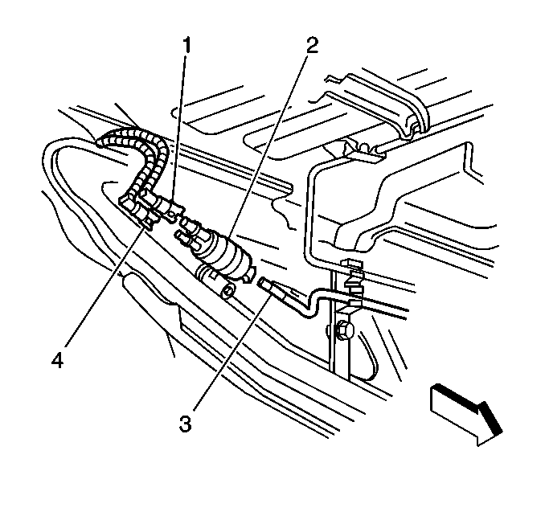
The main fill pipe routes from the cap to the tank. There’s a connector at each end of the fill pipe. One of the early problems was slow filling and GM redesigned the fill pipe to get a better flow.
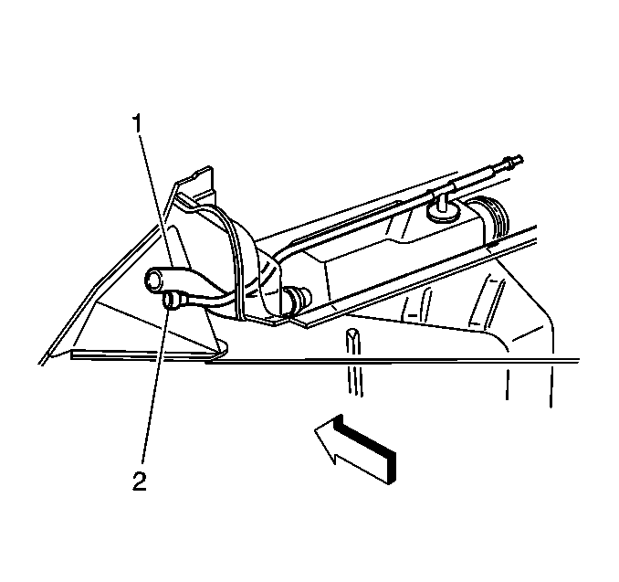
1. Fuel filler hose
2. Vent pipe
Next check the fuel sender, the auxiliary fuel rear return pipe that connects the jet pump to the left tank and the auxiliary fuel feed rear pipe that connects the left tank to the jet pump at the fuel sender. The FLVV hose routes to the EVAP canister. Finally the crossover pipe connects the two tanks but that’s at the top of the tank so I guess it would be hard to see from below.
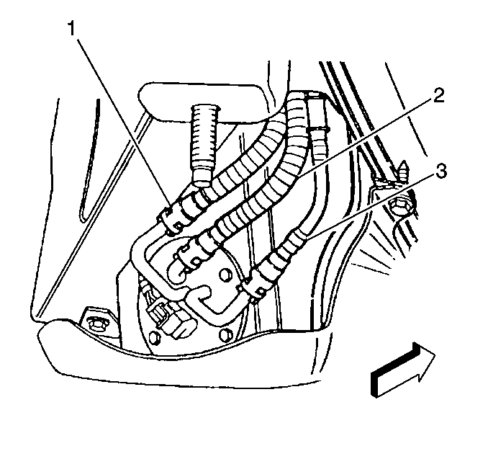
1. Auxiliary fuel return rear pipe from the jet pump to the left tank.
2. Fuel return rear pipe.
3. Fuel feed rear pipe at the fuel sender
If the leak doesn't show until the tank is getting full that would be the time when the fuel is starting to fill the right tank via the crossover pipe. It may give a clue.
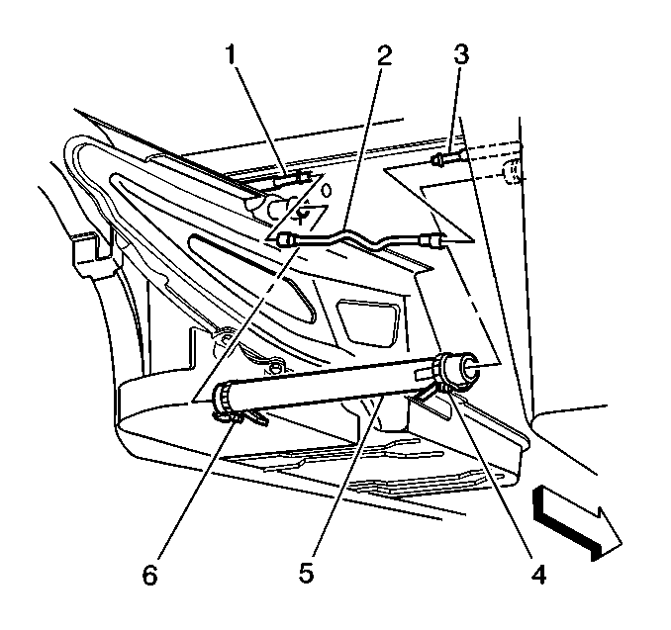
1. Left fuel tank EVAP pipe.
2. EVAP pipe quick-connect fitting.
5. Tank crossover hose 1. Left fuel tank EVAP pipe.
2. EVAP pipe quick-connect fitting.
5. Tank crossover hose
(deloan, Bowie, MD, 11/25/09): I have the same problem. I have a 2004 C5. I started to smell a strong gas smell all of a sudden after filling my car with gas. The next morning I looked under the car and there was a puddle of gas on the floor of my garage. I drove it to a local Corvette shop and they diagnosed it to be either the crossover tube connector or something around it. As rnengnr said, they quoted $2000+. This truly sucks. The good thing is I don't drive the car everyday. Keep us informed about what you find out.

(rebelheart, Lacombe, LA, 11/25/09): Anyone know if the fuel tanks may be covered under the emission warranty?

(2EZ 2SPD, Moyock, NC, 11/25/09):

Originally Posted by rebelheart
I can smell mine but cannot find any evidence of a leak. If someone finds a leak, could you please post a picture and maybe how they found it?
I put a link in post #13 that has pictures in it of my fuel filter with leaks you can see. On mine the smell of gas was strongest near the rear of the driver’s door (same location as the filter).

(rebelheart, 11/26/09): 2004's have no external fuel filter.

(Aussie C5, Sydney, Australia, 11/27/09): I had the same problem with my 2004 a couple of years ago.
I spent a lot of time trying to find the leak. Replaced the stainless steel crossover pipe, put transaxle back in and it still leaked when I filled over half a tank. Problem was the left hand tank had a hairline split on top of the crossover pipe connection.
After years of seeing this problem on the forum, it should have been a recall by GM.
They changed the whole fuel tanks setup for the 2004 models by using a stainless crossover pipe, instead of fail safe rubber and installed the fuel filter inside the tank. I think this was done for new laws introduced and I think it's the same setup in the C6 now. Why did they have to do it on the C5's?

(rebelheart, 11/29/09): According to my owner’s manual, fuel tanks are covered under the emission warranty - has anyone tried pointing this out to the dealer or representative?

(dadsturn, Katy, TX, 12/2/09): I have had the smell but never found the source. After having the car on a lift, I saw where the fuel was coming down and staining the bottom protector plate. I never found any fuel on my garage floor though.
On a trip, I was filling the car up and decided to just look underneath. I saw fuel leaking to the ground as I was filling up. Thankfully I didn’t have any problem past that and it doesn’t leak at any other time, just smells. So I fill only to 1/2 and do it slowly right now and I have not had any problems with smell or gas station leaking.
Has anyone received anything from GM concerning the 2004 problems? It sure seems to be mostly 2004’s that are having this problem.

(rnengnr, 12/5/09): Well, here’s where I am. I looked on the nhtsa.gov website and instantly found 10 hits which I documented. I documented as many as possible on here. I also found a YouTube link of a 2004 burning to the ground for no apparent reason and was obviously not able to be attributed to the tank after the burn but seems obvious to me.
Bottom line is the 2003s had a rubber hose connecting the two saddle tanks - it is NOT the fuel filter NOT the gas cap, NOT the plumbing.
It was changed to steel on two reasons that I read: (1) EPA said the level of hydrocarbon being released into the atmosphere by rubber hosing was above limits. (2) there were many complaints of fuel smell in the passenger compartment. I don’t know which it was but they change to braided steel.
The tank connector on the end of the hose is a twist lock bayonet style and has two o-rings that seal the connector. It does NOT leak. The more rigid crossover hose breaks the plastic molded connector on the tank. This connector is plastic welded to the main tank.
As for the dealer he was a jerk - Kendall Chevrolet. The service manager used Mitchell’s guide to estimate the time. I asked why he was not using the GM book and he told me that was only for warranty work. I got him to reduce the time to six hours for a job that took around two hours. Remember he told me the transaxle had to come out - 10.5 hours. He had the standard BS used car salesman attitude.
So I called GM to complain about the faulty parts and the cost of the labor and the lies that were told to relieve me from my money. GM listened to my complaint with the standard off shore " I am sorry for your trouble" " I will help you, I am assigned your case" blah blah. After three weeks and two "regional service representatives" I told him that I needed to speak to someone in Detroit and I was going to start calling PBX extensions in the Detroit offices until I got someone to listen.
The third representative said he could not offer any relief on the part (which is what I wanted since NTHSA entries indicated that the representative or dealer reduced or eliminated the cost of the tank on the repair). He offered coupons on the next car I might buy, all kinds of options, etc.
I will post my final decision once I have it in my hand however I bet if you pushed harder and used my information you would be able to do better than me since I was out of patience.
I have a huge file that could be scanned and distributed if anybody wants it. My total cost on this was $1450.

(rebelheart, 12/6/09): It seems some late production 2003 models may also be affected.

(rnengnr, 12/7/09): Checked my mail and there was a three year, 36K mile card for oil changes. Since this dealer charges me 98 dollars for an oil change, I figured I would be visiting a different dealer and use the card for all its worth. I guess at 36,000 miles that’s at least seven oil changes.
I will be exploring the possibility of the emissions side of this thing as well.
AND, SO................... guess who called today?
DOT - asked for my entire file and photos of the tank and asked if I would be willing to donate the tank to their research facility.
Now we're having some fun! I have the DOT agent's email address and phone numbers. He asked that who ever has had this similar issue please fill out the HTTP://WWW.SAFERCAR.GOV form and leave an E-mail and/or phone number.
This includes all who have had this issue fixed under warranty. If there is a way to put this request on the web login page it would help those of us who have had the bad luck of having it happen just after the warranty ran out.

(rebelheart, 12/9/09): It took almost 40,000 miles for the problem to show up in my car.

(rnengnr, 12/9/09): I developed my smelly car around 40K miles. Any smell of fuel is a hint so be careful. It starts very slowly and drips off the tank protector under the driver’s seat.
If you stick your hand right under the car where you sit, touch the metal just behind it and your hand smells like fuel, you can bet that’s what’s starting.
(rebelheart, 12/10/09): Here is a phone number and contact name you can use to report this also to the NHTSA. Nathan Ong 1-202-366-5224.Give him a call as he says the more reports the better!

(20mercury, Lafayette, LA, 12/11/09): Here is an excerpt from an email from one of my Corvette Club buddies:
I would like to bring a serious safety issue to the attention of any of our members who own a late production 2003 and all 2004 Corvettes. Due to a design change, the left hand fuel tanks crack and/or leak at the new metal crossover tube. This allows fuel and fuel vapors to leak and fumes to flood the cabin. This is a very serious safety issue (not to mention an emission law violation). GM has taken the stance that the cars are out of warranty even though emission warranties are for 80,0000 miles. The dealers want $2,400 to replace the fuel tanks as this is the only repair. Can you please let our members and the members of our sister clubs know they can go to www.safercar.gov and register a complaint if they drive one of these model Corvettes. They can also call Nathan Ong at the NHTSA - his number is 1-202-366-5224. Let’s hope we can get GM to fix these cars before more burst into flames!
What a bummer, can you replace the braided stainless steel hose with a rubber hose before it breaks?

(hub_cap, Marietta, GA, 12/11/09):

Originally Posted by deloan
I have the same problem. I have a 2004 C5. I started to smell a strong gas smell all of a sudden after filling my car with gas. The next morning I looked under the car and there was a puddle of gas on the floor of my garage. I drove it to a local Corvette shop and they diagnosed it to be either the crossover tube connector or something around it. As rnengnr said, they quoted $2000+.
I have a 2004 Z06 that had the same gas leak on driver’s side, fixed under original warranty. Dealer said that the crossover line was cracked and replaced. No trouble since.

(HEB, New Lebanon, OH, 12/12/09): Driver’s side tank and crossover pipe replaced on my 2004 Z06 at 600 miles. No problems since.

(rnengnr, 12/23/09): Tomorrow I will be sending my GM files to Nathan from the DOT at his request along with my VIN and warranty history, repair history and invoice for this repair. I have the old tank and intend to post photos with help from thread members.

As for switching to rubber hoses, I bet it’s a lot of work since you will need to get to both sides of the hose, left and right but I am sure this will solve the issue unless yours is already starting to crack.

Nathan Ong, Defects Assessment Division, Office of Defects Investigation, NHTSA, 202-366-5224 (w), nathan.ong.CTR@dot.gov .

Latest from Nathan: Rick if you can simply give me a rough estimation of the dimensions and weight of your tank, I will mail you a prepaid shipping label. Thanks for the response regarding your tank and the video. After looking at the video, the fire seems pretty serious, but also inconclusive as to the cause. If you can find more information regarding the video, please forward it my way. Thanks, happy holidays/new years! -Nathan Ong

(rebelheart, 12/29/09): Indeed, the only real fix for this very serious issue is replacement of the fuel tank itself! It is an obvious design flaw which GM should be forced to address like Ford did with the Pinto!

(Jims Z06, Sterling, IL, 12/31/09): I have a 2004 Z06 I purchased in September 2008 with 5500 miles on the clock. This past November when fueling it up, gas started running out from under the car on the driver's side (10,000 miles). Thankfully this was at a Shell gas station that had a car wash with an underbody flush.
I just finished E-mailing Nathan, and will register my complaint with NHTSA also.
My car was modded in September with an A&A kit and upgraded in-tank fuel pump as well. Car has been fine until recently. Will this "void" any claims I might have?
I also will be contacting the dealership to see what they have to say about it. The "squeaky wheel" gets the oil, so let’s start squeaking out there!

(marliner, 12/31/09): My wife’s 2004 Corvette did this and it was very aggravating. The dealership was not helpful as the car was under warranty after three repairs they finally replaced the tank. After that the car had a clunking sound and the dealer said he couldn’t find it. She traded for a C6, problem solved.

(Jims Z06, 12/31/09): I know it was very nerve wracking (scary) as I know my headers/cats/mufflers and pipes were very hot and I stood there and saw gas running under the front of my rear tire and towards me. Like I said I had the underbody flush done immediately if for nothing else peace of mind.
"Nathan" returned my E-mail almost immediately and seemed very interested.

I also just finished registering the complaint with NHSTA. If you have had or had issues register your complaint please.
(Cockatoo, 1/4/10): Well, now that the holidays are over, I guess I will bite the bullet and take mine in for a repair. I have test driven it a couple of times in the last two months. It does okay and doesn't smell of gas until it starts to cool down and then a spurt of gasoline is emitted. It is enough to make it come out of that little tray just inside the rear, driver's side tire. Once it dries out, the smell goes away until I drive it again.
May car is a 1998 with 6300 miles. I will talk to the service manager before the work and demand the right to take pictures of any pieces they replace. Actually, I think they should give me the parts if I pay for replacements. I am not filling out any complaints until I get the car back and see how bad it really is. If you guys can think of anything else I should do beforehand, please reply. I am gathering the bill will be between $1400-2400 if this thread is any indication. I plan to try and reclaim this money too!

(rebelheart, 1/5/10): Being that you have a 1999 model ,this would be a completely different issue. This problem is limited to late production 2003's and all 2004's.

(y_cashmoney, 1/5/10): I also have a fuel problem with my 1998 C5 with 120K miles. After driving, it smells bad (fuel smell) and leaks or drips in the rear middle of the car in front of rear tires where exhaust is. Any idea what would cause it because it’s getting worse? Maybe coming from different location and running down gas tank pan/mount?

8VETTE7, I think you’re right because I took a look online at the location of the fuel pump and that is exactly where it is leaking from. Now it's time to get it on a lift and get to work.

(JGO200, Bend, OR, 1/10/10): My 2004 Z06 (19,400 miles) started exhibiting this when I put it away for the winter. In November I warmed it up in the driveway and put it away the garage and (later) house reeked of gasoline. It went away so I sort of ignored it until I got an email from MyCarStats.com notifying me of this emerging problem. Today I did the warm up thing again and it was just as bad.
Filed a NHTSA report today. They'll have to fix this - it's not only an emissions deal but somebody's going to lose a garage or house.

(rebelheart, 1/16/10): The smell is of raw fuel on the inside of the car and mostly around the left rear of the car. The smell you describe may be small oil seepage onto where your exhaust bolts to the head from the rocker cover.

(vette3800, Lexington, SC, 1/17/10): A design change was made during 2003 to the fuel crossover fuel line between the tanks to a "upgraded" stainless steel hose. Some 2003 Corvettes and most 2004 Corvettes could have this problem. There were some tolerance problems at the seals. It is a major repair. Please file the complaint with NHTSA. GM knows about the problem and is keeping silent to avoid a recall.

(Jet-Jock, Lake Mary, FL, 1/18/10): I'll help keep your post alive. My 2001 seems to have a few of these symptoms and I will doing an inspection today to see if I can identify where or what is generating the fumes. The fumes only occur after fill up (just letting it do the auto shutoff when filling), and can only be sensed near the one o'clock position on the passenger side rear wheel well, not aft of the 12 o'clock nor further down towards the frame rail. Just one area. If I drive it a bit and burn down a gallon or two the fumes fade off. Then I'm fine until the next fill up.
I have pulled both tires and inspected the line interface - there is no evidence of a fuel leak. Neither is there any evidence on the floor. So I know that the evaporator canister is located on the right hand side, but it is going up on ramp to get a better look, then if nothing is obvious I will pull the wheel again today and access where the evap canister is to see what that animal is looking like.
Albeit the vehicle is just nine years old with not even 50K on it, this is stunning that Chevy created such a flawed designed and neither is standing behind the product to fix it nor is the government safety agencies designed to protect us from these mega corporations doing anything about it either. Except to take your complaint.

(rebelheart, 1/18/10): Your 2001 has completely different fuel tanks and crossover pipe, so a different problem entirely.

(Jet-Jock, 1/18/10): Similar in the sense that another C5 is affected with a possible fuel leak in the tank system design. But I understand the unique problem that comes with the 2003-2004 redesign of the cross over, a pre-C6 design.

(medman1, 1/24/10): My 2003 had the same gas leak. Had to pull tank -$2400.00 later --maybe the leak is fixed. Totally stupid Corvette design. GM should stand behind their faulty design.

(ivan84gt, Miami, FL, 1/26/10): Had the same problem on my 2004 Z06. It happened with about 8000 miles on the car. Garage started to stink of gas. Thank God for CarMax extended warranty, got me a new set of fuel tanks.

(dadsturn, 2/1/10): Well, I cant wait any longer. The car is going into Vettetech today to have the tank and tube removed and replace what ever needs to be replaced.
I will make sure to get pictures as we go, so that it is documented, and I will forward onto NHTSA. I am at the point that I don’t believe GM will step up to the plate, and I am not putting my life on the line awaiting for NHTSA to put this to GM or for GM to sit back and ignore it.
Right now, I am blaming NHTSA for not aggressively moving on this with GM. I am sure that enough "LIGHT" has been brought before NHTSA on this circumstance, and I don’t really think they are doing anything with it.
I have attempted to call them to check on the status, and can never get through. I have left messages, telephone number, and nothing! If something does happen, then I will try to recoup my cost. But we are still dealing with a government department so it may take eternity for them to put two and two together.

(ChargedGN, Nazareth, PA, 2/1/10): Just bought my 2004 last year with 7K miles on the clock, and it is my daily driver and now at 20K miles. No issues as of now, she's up on the lift for the winter.
Previous owner said the only issue he remembered was with the fuel pump going bad but wasn't sure - I will have to look at the receipts to see what was done. Could the dealer have screwed it up even more taking it apart and back together again? Good thing I renewed the GMPP for another 3 years\55K.
Are they replacing the faulty tanks with the same designed tanks and crossovers? Wouldn't this just fail again in time? I figured buying a 2004 that GM would have all the bugs worked out by then.

(Jims Z06, 2/12/10): If the problem is fixed...new crossover and tank...what is different? Is the tank redesigned? Strengthened in the hose connecting and bung area?

(Jet-Jock, 2/12/10): I know my issue is not the same as the original poster's issue with the cracked tank from the crossover, but this keeps the post alive as well.
There are some differences across the years, most specifically late 2003 and 2004. But the modification did not improve the situation - instead it is more vulnerable to cracking. The late 2003-2004 feeds from the top and the others from below. The crossover pipe connects across the side to side while the newer connects to the top. There was a picture around that showed the new tank.
I had my 2001 in for service today for fuel vapors on a full tank. Just under $300 to do a leak test and pull the tank. Could see evidence of some residual around the strainer but not fresh fuel. They best we could figure is a vent to outside air may be intermittent. While Chevy mechanic had the tank out he put beads of SMC adhesive around the subject components in hopes it might seal it up just in case there are leaks. If it happens again, it requires a new tank.
Courtesy Chevy in Orlando is really a great dealer. They let the Corvette folks go back freely to talk to their Corvette mechanic and discuss your car. I've never seen a dealer do that. I've been escorted before but not allowed to just go back and forth. Any way I watched the smoke test and no evidence of a leak, so we decided to drop the right tank and see what is going on. Didn't take him too long. A complete inspection didn't show much. Just the residual we saw earlier from viewing it through the EVAP canister opening. So, he sealed it, and it'll be a try and see from this point.
(rebelheart, 2/13/10): The case, as in any recall, would be a new design that would repair this dangerous situation. When a recall is made, it is to correct the condition, not to just to replace parts with the same thing. Probably why GM is avoiding this at all costs.

(ivan84gt, 2/14/10): I had the same issue at around 12K miles. I got my car from Carmax with 8K miles and got extended warranty so they installed a new set of tanks. I didn’t have to pay for it (warranty) but I saw the paperwork from Carmax showed the cost around $1600. I just filed it in safercar.gov.

(rnengnr, 2/16/10): By the way, I just checked the NHSTA website for complaints on the tank and its up to 30 or so. The number of fuel system complaints on 2004 Corvettes totally overshadows the other complaints on that search making it the number one complaint on that vehicle for that year on the NHSTA complaint search.
I haven’t seen any investigations on that site yet, so those of you going to get the tank fixed use http://www-odi.nhtsa.dot.gov/complaints/index.cfm. Print all the tank complaints before you go to the dealer and wave them in their face and tell them you want to speak to the "Regional Service Rep." A call to GM wouldn’t hurt as well.

(dadsturn, 2/16/10): I sent the pictures of the tank to NHTSA this morning. Steve responded with saying that the issue has been forwarded and it will be decided "in turn", whether a formal investigation is warranted, and that "it may take some time".
I stated that I knew there were more complaints on this than the Toyota incident and that Corvette owners were disgusted with the way this has been received and dealt with. I also stated that I hope that this gets the action it needs before someone has to die in order for it to come to light.
If I knew how to post pictures on here I would. If anyone has an email, I will send them to you and let them post them. We found two places that showed a fuel trail. One from the connection to the crossover, and one from a seam that looks very bad. This seam is where the molded halves were melted together. So right now it looks like everything is getting replaced and I am awaiting the bill.

(Dave 2003 TRZ06, Cypress, TX, 2/16/10): Pictures from dadsturn's defective tank:
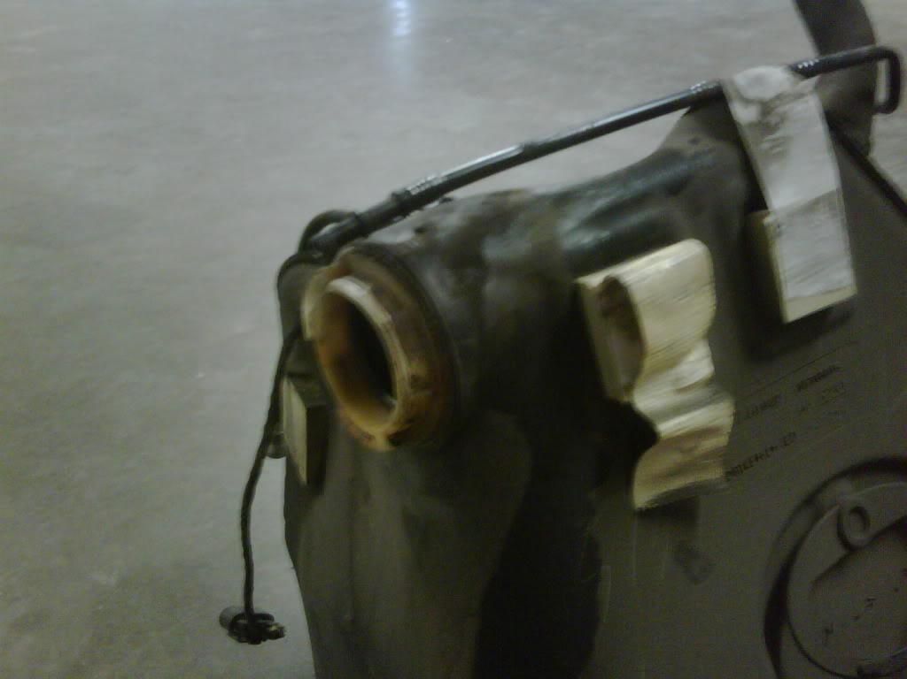
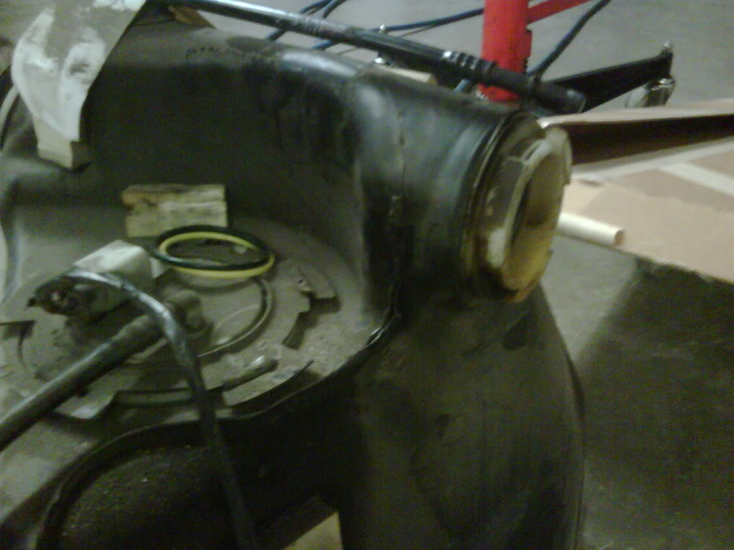
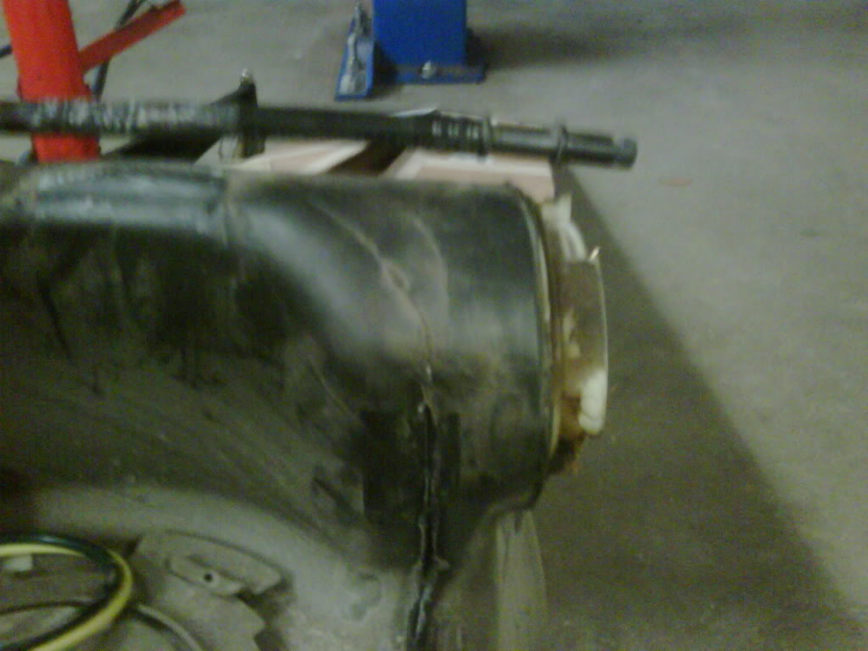
(ChargedGN, 2/17/10): This question is to dadsturn and others that had their tanks replaced. What exactly was done? Did they use new parts or was it just replaced with the same flawed design pieces?
Doesn't make sense to use the same parts just to have this happen again in time. If I could fix the problem before the tanks crack I will. I was thinking about dropping my extended warranty to modify the car but with this going on I will need to keep it stock.

(Jet-Jock, 2/17/10): The emissions warranty covers the fuel system. Non-California cars are 8 years/80,000 miles, California cars are 7/70.
I'm not sure on GMPP, it probably should be covered. Generally the service advisor needs to call the codes in and the system tells them whether it’s covered.
Yeah they use the same parts. Sad. Owners have a legitimate complaint here and a right to be upset.

(dadsturn, 2/17/10): I am having to replace the fuel tank and crossover, inter lines that run inside of the crossover. The bill will exceed $2,000.

(ChargedGN, 2/17/10): I wonder if you could request the 2000-2002 tanks and crossover setup instead of the proven failed 2004 setup under the GMPP warranty? My GMPP warranty is bumper to bumper so I would assume it would be covered, I will check to see.

(rebelheart, 2/17/10): I am not sure but probably the older parts supercede to the newer "faulty" part numbers.

(Jet-Jock, 2/17/10): I don't believe they would do it, even if everything fit, because the car was certified with the new fuel system. As I understand it, the old system leaked too many hydrocarbons into the atmosphere via the cross over hose. The evil environmentalist (LOL) I believe caused this change to happen. The in/out line interface would be different. Old system feeds from the bottom while the newer design feeds from the top. So it would be one heck of a deal to replace all parts, and I doubt you'd get them to pull that one off.

(rebelheart, 2/23/10): I received an e-mail from the NHSTA stating this issue is "under investigation," what ever that may mean.

(Green Hornet, Virginia, 3/4/10): I have a 2001 coupe that has a strong gas smell in the garage and in the passenger compartment after I fill up. I'm very careful NOT to overfill or top off. I've taken it to the local Chevy dealer (who replaced the fuel filter not long ago) but he cannot find a leak. The smell goes away after driving it a while. Any suggestions?

(Jet-Jock, 3/4/10): Yes, you are probably in the same boat as I (2001 convertible). There is a check valve in the tank that is venting to the atmosphere, but is not functioning properly. Sadly the fix is to replace the tank. About 2.1 hours labor from Chevy, the price of the tank varies depending on where you shop and if you can get your dealer to deal on the parts.
Look at the step section of the tank where the vent tube connects, and the electrical connection with the other end hanging free. Just to the rear of the darker blue connector is a tube pointing to the left in the picture and is the valve (not the brighter blue inter-tank connector seen at the top of the tank). This is what your right hand tank looks like. I had them drop the tank in an attempt to find the source of the fumes. While it was out they did seal all interfaces as you can see in the picture, but that did not solve the problem sadly. So it will have to go in again in the near future to have the tank replaced. Right now I don't put any more than 3/4 of a tank of gas and that keeps the fumes in check. Unless I'm going somewhere to require a full tank and it will burn off some of it en-route.
After you burn off a few gallons it's OK again. If you fill up and park it you can smell the fumes terribly around the passenger rear wheel well correct?

(rebelheart, 3/5/10): This is a completely different issue but should be reported the NHTSA also as it is an obvious emission issue. It seems GM is covering up multitudes of fuel tank issues on their flagship sports car!

(CatCam, Jesuit Bend, LA, 3/6/10): For those of you with cracked crossovers how many of you have the Z51 upgraded suspension? The reason I'm asking this is I want to see if the stiffer ride could add to the stress on the crossover. I know this is a design issue I just want to know if the cyclic vibration by the stiffer suspension is a factor.

(rebelheart, 3/6/10): I have the Z51 option ,but I don’t think it adds to the problem.

(Aussie C5, 3/6/10): Mine has the Z51 package and leaked badly. Good point, could be.

(rebelheart, 3/7/10): Three of my local club members with this problem do not have the Z51 option. It may contribute is some way but is not the defining cause.

(CatCam, 3/7/10): I was just reaching on the Z51 thing, seeing if there was some correlation. But this is just on the late 2003's and 2004's, right?

(rebelheart, 3/7/10): Yes, just late production 2003's and all 2004's.

(VR-4ever, Virginia Beach, VA, 3/9/10): How can I find the production date on my 2003 convertible? If I have the fuel system with the internal fuel filter (no external one) does that mean I'm in the risk pool? Second, does anyone know exactly where it leaks so I can do a visual? When up under the car you can clearly see the cross-over connector.
EDIT: Just read the whole thread. I do indeed have the "upgraded" fuel system in my 2003 convertible. So to be clear it can leak from two places:
1. The white connector can crack
2. The actual tank can stress-fracture
Anywhere else so I know what to watch/look for?

(rebelheart, 3/10/10): The o-ring sealing surface of the cross over tube also can distort and cause a leak.

(dadsturn, 3/11/10): I have just been contacted by Steve @ NHTSA. They want pictures and also the repair bill sent ASAP.

(deloan, Bowie, MD, 3/11/10): Where can a get a break on a gas tank for my 2004 Corvette? Spring is here and I have got to get on the road. GM is talking $900, just for the tank alone!

(rnengnr, 3/14/10): I haven’t heard anything for a month or two so I should E-mail Nathan to see what’s up. To address the Z51 question, mine is the CE coupe with magnetic selective ride which is off 99% of the time. It seems like the crossover pipe was a band-aid in the last year of production that caused other problems.
(dadsturn, 3/25/10): I sent pictures of the bad tank and crossover along with the invoice to have it done to Steve @ NHTSA. He stated that he forwarded it to higher above. The claims are now being reviewed by the engineers, to see if there is justification to make GM claim responsibility.

(Cockatoo, 3/25/10): Okay, I have a 1998, not a 2004, but still had a messy leak. I waited until I could manage $2000 USD and took it to the dealer - Hood Chevrolet, in Covington, LA. I told them I wanted any parts replaced. They called me the next day and I had a ruptured o-ring at the fuel pump. So, I ended up getting a new fuel filter and an oil and filter change with the repair for $176! I'm a happy camper but I really feel for you guys suffering through that crossover mess.

(dadsturn, 3/26/10): This is a letter I sent to Steve at NHTSA on this issue:

As you may know, there are a great deal of people with 2004 Corvettes that are waiting to see what is going on with our problem. We also understand that the NHTSA is very busy with Toyota.
Is there any update that you can supply me with or a channel to someone that can give us the status of the complaints? The repairs have cost the Corvette community a great deal of money, and those that can’t afford to repair this problem are paying for cars that they can’t drive without The possibility of an explosion.
The thoughts of the Corvette community right now is that the NHTSA is sitting on this due to Obama Motors. I know it sounds stupid, but there seems to be some merit in this with the financial situation GM is in right now.
I don’t believe that this is asking too much from the NHTSA to give us some type of feedback where the situation is at.
It’s unfortunate for you that you are my only contact concerning this situation. Again, someone please give us some information or direction that the complaint is going.

(04vetteuy, 3/28/10): I just had my tank replaced for the smell total was right at two thousand dollars. Is it true the transmission has to be dropped to do repair? Labor was just as much as part.

(rebelheart, 3/30/10): It may be able to be done by tilting the whole drive train, but not really sure about that, labor would be about the same any way.

(kennya35, McAlester, OK, 4/1/10): I have never noticed this with my 2003 coupe, but right now I am in Kuwait and I want to inform my wife that if she smells this, to quit driving it. But I would also like to know how I can tell if mine is affected by this change GM did. Has anybody researched it to the point of knowing when GM did switch to this faulty system? Can you tell by your VIN? Or is this something I am going to have to take care of by digging around when I get home?

(8VETTE7, 4/1/10): 2003 gas tank changed with VIN 35111542 - beginning on date November 25, 2002.

(~Joshua, 4/2/10):

Originally Posted by Inkmann
Is this something I should be concerned about. I am looking at a 2004 with 9800 miles. Is it mileage related? Should I have him fill the tank before I look at it again?
It has about 1/4 tank in it now. Is there any work if GM will warranty this?
He should give you a full tank anyway. Might as well ask him to fill it before you decide (if other things about the car checked out already).
From an engineering standpoint, you'd think it has to do with the amount of chassis flex. The idea about whether the plastic fuel tank material is becoming more brittle with time/age and thereby subject to a reduced flex resistance is the most interesting as our cars mature.
GM Warranty? They don't even want to acknowledge this! Do you have any idea the liability? It would also tarnish the Corvette nameplate if the mainstream media bites into this.

(8VETTE7, 4/2/10): This is not covered by the GM warranty. That’s a big part of this whole thread. Cost is out of owners pocket and is generally $2000 and more. It does NOT appear to be mileage related. If you have to pay for a repair out of your pocket you will be worried.
Some aftermarket extended warranties that you can purchase DO cover the tank. Make sure if you are purchasing one that the tank is covered.
Originally Posted by Inkmann
If I am understanding this correctly a 2003 with a VIN # of 1G1YY22G135116700 would or could be affected? That’s my second choice car (the 2004 I mentioned above is my first).
The 2003 has the new tank system according to the VIN you have provided. The 2004's all have the new tank.

(KCvetteowner, Overland Park, KS, 4/9/10): I'm looking for clarification on a couple things:
1) Sorry I didn't read every post but about 3/4 of them. Did anyone mention what the "actual" fix is? Are they just putting the same flawed design tanks back in your car so you can expect to do this again in a few years or is there a newer crossover now?
2) What's available from a parts stand point. If I have a 2002 and need my gas tanks replaced has the flawed design superseded the part number for the 2002 models? Do I order 2002 tanks for my car - does an owner who is effected by this bad crossover design ask for 2002 tanks be installed and add an external fuel filter, because that's what I would ask to be done.

Originally Posted by rebelheart
As in all recalls, GM would be forced into a redesign of the affected parts to repair the condition. This would mean newly designed fuel tanks at the very least. Exactly why GM is dodging the issue until it is out of date.
So you are saying that since this isn't a recall that the fix is to install the same crap they took out?? Couldn't you just tell them you want the 2002 tanks and install the 2002 fuel filter outside the tanks?

(8VETTE7, 4/9/10): See answers in blue below.
Originally Posted by KCvetteowner
I'm looking for clarification on a couple things:
1) Sorry I didn't read every post but about 3/4 of them. Did anyone mention what the "actual" fix is? Replace failed components. Are they just putting the same flawed design tanks back in your car so you can expect to do this again in a few years or is there a newer crossover now? Yes. There is no "upgrade" for the components that fail at least as of this time. So the same parts that may well fail again are installed as the repair. That's the only solution currently available.
2) What's available from a parts standpoint. If I have a 2002 and need my gas tanks replaced has the flawed design superseded the part number for the 2002 models? NO. The earlier tanks and cross over hoses are what get put into a pre 2003 car. The earlier cars have a completely different tank system than the later year cars. The tanks for the mid 2003 and all 2004 cars are a completely different design than the 2002 and earlier system. The new system cannot easily be installed into a 2002 or earlier car and the older tank system cannot easily be easily put into the mid 2003 and 2004 cars. Do I order 2002 tanks for my car, does an owner who is effected by this bad crossover design ask for 2002 tanks be installed and add an external fuel filter, because that's what I would ask to be done.

(Inkmann, 4/9/10): How many cars out of 33,000+ have been affected so far? 30? 300? 3000? Is there a common denominator, like build date, mileage, part of the country they are in?

(VetteSiNz, Jacksonville, FL, 4/9/10): This happened to my 2004. Six months after I bought it in 2004, I smelled gas every time I filled up the gas tank and also saw a puddle of gas under the gas tank. Brought it to the dealership and the mechanic found the crossover pipe was cracked and one of the tanks had a bad seal on it. Also the filler tube seal was bad. I had to wait at least a week for all the parts to came in and repair done. What I heard is that the gas tank on 2004 is the same tank for the 2005 and up model. Some more information:
http://forums.corvetteforum.com/c5-t...gas-smell.html
http://forums.corvetteforum.com/c5-t...s-already.html

(J.Abbott, Mechanicsville, VA, 4/13/10):

Originally Posted by VR-4ever
How can I find the production date on my 2003 convertible? If I have the fuel system with the internal fuel filter (no external one) does that mean I'm in the risk pool? Second... does anyone know exactly where it leaks so I can do a visual? When up under the car you can clearly see the cross-over connector.
EDIT: Just read the whole thread. I do indeed have the "upgraded" fuel system in my 2003. So to be clear it can leak from two places:
1. The white connector can crack,
2. The actual tank can stress-fracture.
Anywhere else so I know what to watch/look for?
I believe it was VIN 11,000 and later.

(8VETTE7, 4/13/10): An earlier post in this thread specifies the exact VIN when the change took place for the 2003's and the date that occurred on.

(rebelheart, 4/16/10): GM claims it is not covered under emission warranty and GM is completely dodging the issue in hopes they wont have to fix them. No recall slated as yet - we have to keep pressuring the NHTSA!

(SMC_Crash, Los Angeles, CA, 4/16/10): That's a load of baloney. That's the #1 reason I won't buy a new GM ever again. They're such schmucks when it comes to keeping their customer's happy. And they certainly don't take responsibility for screw-ups like this. Leaky butt, column lock, fuel bridge and seals, etc. All problems they could fix permanently but they don't. $50K+ car and they still don't do anything about it. That's just not OK with me.
I'm looking at buying a 2003-2004 since my 2002 was totaled. If I get one of those years, I'll fill out the form.

(8VETTE7, 4/16/10): If you can find a 2003 prior to VIN 35111542 you will have the early gas tank system which will not have the problems discussed in this thread.

(rebelheart, 4/25/10): I know of no way to tell you the exact number of cars affected, though sooner or later, all the target cars will be. As we just started to pursue this issue with the NHSTA the numbers are just starting to climb.

(Z06supercharged, 5/5/10): I have a late 2003 with 58K miles and no problems (yet) with leaking fuel tanks or crossover tube/connectors and I beat the living daylights out of the car every time I drive it. FYI: the connector can be undone and tank dropped without dropping the cradle/drivetrain. I’ve seen it done several times at a dealership and by a owner in his driveway. If mine ever leaks I’ll yank them out myself and fix it myself or change up the design tube/connectors.

(vette3800, Lexington, SC, 5/5/10): This problem started during the so called upgrade change to stainless steel fuel crossover hoses during late 2003. I have been thru all of this with my 2004. At 13k miles, dealer refused to cover it under warranty. My local race/tune shop did my work for me and it is documented in detail with pictures which I have reported to NHTSA. If enough people complain and enough fires occur, maybe they will do something. Everyone, please report these factory screw-ups.

(MSG C5, 5/6/10): I have a 2004. I threw a code and also smelled gas after a fill-up. Turned out to be a damaged carbon cannister. They replaced it under warranty as well as the cross over bar.
(adgeorge, London, KY, 5/9/10): I became aware of this problem sometime ago and was dreading it. I have owned my 2004 lemans coupe for about three years and it has 27k miles. Yesterday I took my car out for the first drive of the year of about 200 miles that included a fill up at the local station brought it home and parked it in my attached garage. About 1:30 A.M. woke up smelling gas though out the whole house and my wife woke up about the same time smelling gas. I knew at once that I was going to have to take my turn dealing with this issue. This could have burned down my house with my wife, child, and me in it.
I would like to put my Corvette back inside but I am not going to as long as I have a full tank of gas. Does anyone know how to remove the gas from the tank? I couldn't get a hose in the tank to siphon the gas level down.

(rtpilot, Media, PA, 5/9/10): I once put the wrong fuel in my 2004. I found a description on the C5 Tech forum on how to drain the fuel from the fuel rail by jumping out the fuel pump relay. Do the search, the post was very clear and comprehensive. http://forums.corvetteforum.com/c5-t...rail-line.html

(93Ruby, Mesa, AZ, 5/11/10): I have a 2002 coupe and purchased it about six months ago with 42K on the clock. Now has gas smell after filling up and sitting in garage overnight. No leaks around tanks or filter. Where do I begin?

(8VETTE7, 5/12/10): Start with the fuel filter. Most likely the problem you are experiencing is NOT related to the issues that is this threads focus since your car is neither a late 2003 nor 2004 which exhibit the tank problems. You might also check the carbon canister (pull codes) which can be the cause of fuel odor on the earlier cars.

(Swiftrider08, Rushsylvania, OH, 5/12/10): I was sent a PM asking to post the picture below. Pretty much all the same for the C5 and C6. This picture might already be in this thread, but I did not look.
Also, check out this document from GM.
http://www.hessh.de/Corvette/FuelTankSystem.pdf
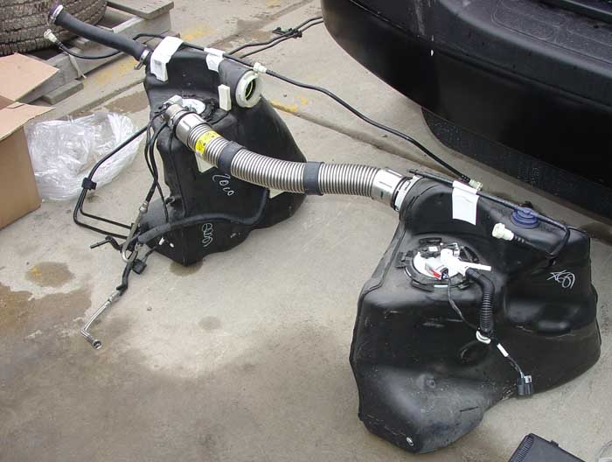
(RedSoxFan, New Hampshire, 5/17/10): Investigation is underway: http://www.examiner.com/examiner/x-1...ation-by-NHTSA

(mpride, Sugar Land, TX, 5/17/10): I believe this is the direct link to the NHTSA page: http://www-odi.nhtsa.dot.gov/defects...intVersion=YES

(Jims Z06, Sterling, IL, 5/18/10): Went cruising with the wife over the weekend and when I stopped for gas (try to keep it at 1/2 or under) my calculations were off and saw gas running under my driver's side rear tire. My fault, but I'm trying to hold off on repairs. Maybe I should have it repaired and hope I'm reimbursed. I haven't had any trouble as long as I keep it around 1/2 tank but less than 3/4.

(CatCam, Jesuit Bend, LA, 5/18/10): http://www.insideline.com/chevrolet/...uel-leaks.html
Just the Facts:
* NHTSA is investigating a flaw tied to fuel leaks in the 2004 Chevrolet Corvette.
* The investigation affects an estimated 33,000 vehicles.
* Office of Defects Investigation for the agency has received 30 complaints from consumers.
WASHINGTON — An estimated 33,000 2004 Chevrolet Corvettes are being investigated by the National Highway Traffic Safety Administration for possible fuel leaks.
The Office of Defects Investigation for the agency has received 30 complaints from consumers "alleging either liquid fuel or fuel vapor leaking from a fuel tank," NHTSA said in its defects investigations summary. "The subject vehicle is equipped with two fuel tanks. In 12 of the reports, a fuel tank was either replaced or identified as the source of the leak."
In other documentation, NHTSA reports no crashes, injuries or fatalities linked to the complaints.
In one complaint posted on the NHTSA Web site, an unidentified consumer wrote: "I had the car repaired by the Chevy dealer on January 12, 2010 at a cost of $2,083. The repair consisted of replacing the left fuel tank."
Another wrote that "our 2004 Corvette with 27,630 miles [on the odometer] suddenly began leaking gas fumes so severely in our garage that we were concerned we could have an explosion."
Another wrote that "this is a safety hazard as the gas tank and leak comes right over my dual exhaust and could cause a fire."
A defects investigation is sometimes the precursor to a recall.
The Corvette defects investigation was launched on May 12. It comes as the U.S. Congress is zeroing in on auto safety issues following record recalls by Toyota.
The U.S. Senate Commerce, Science and Transportation is scheduled to hold a hearing at 2:30 p.m. EDT on Wednesday to discuss new auto safety legislation dubbed the Motor Vehicle Safety Act of 2010 and drafted in response to Toyota's handling of its massive recalls. The House Energy and Commerce Committee will hold a hearing entitled "update on Toyota and NHTSA's response to the problem of sudden unintended acceleration" at 10 a.m. EDT on Thursday, May 20.
The Senate bill is similar to a measure now being considered by the House of Representatives. Both would set standards for pedal placement and keyless ignition systems. The proposed legislation would also require all new cars and light trucks to be equipped with event data recorders and brake override systems.
Inside Line says: If you own the aforementioned 2004 Corvette, be aware of the federal investigation. Also be aware that there are two major congressional hearings this week regarding auto safety. — Anita Lienert, Correspondent

I'm skeptical on the recall. If it is costing the dealerships approximately $2,000/car to fix this problem and they have 33,000 Corvettes affected then this will cost GM $66,000,000 ($66 Million) to fix. The government is NOT going to let their "favorite son" pay out that kind of money.
They will come out with some story that if it does leak they will repair it for free but I don't see a mass recall. Just my gut feeling.

(8VETTE7, 5/20/10):

Originally Posted by SCM_Crash
Bad press about an old model? I doubt that'll be an issue. All they have to say is this problem doesn't exist for the current model.
My question is do we in fact know this problem doesn't exist in the new model? The fuel tanks are the same in the C6 as the C5 (year = late 2003 and all 2004).

(SMC_Crash, 5/20/10): As far as I know, this is limited to late 2003s and all 2004s. If anything, they would have redesigned the gas tanks on the C6s because the exhaust setup is completely different.

(VetteSiNz, 5/20/10):

Originally Posted by 8VETTE7
My question is do we in fact know this problem doesn't exist in the new model?
The fuel tanks are the same in the C6 as the C5 (year = late 2003 and all 2004).
That is what the dealership told me when they replaced the right side fuel tank, crossover pipe, seals and filler tube. This was done in 2004 after just over six months of ownership due to my complaint to them about fuel leaks.

(Jims Z06, 5/20/10):

IGO200 Jim Z06! File a complaint with the NHTSA it only takes a few minutes on line. I'm fine with a "fix on failure" because my Z06 is parked waiting for them to pay.
Oh believe me I did - quite awhile back. Confirmation #10297714. Had numerous correspondences with them along with a phone conversation. Hopefully we are on our way guys - at least it is being acknowledged now. We'll have to see where they go from here, but now that it's out in the open and if something were to happen and the news is out, that would spell disaster for GM. So maybe, just maybe.

(stano, 5/25/10): http://editorial.autos.msn.com/artic...mentid=1145204 This is what showed up today.

(PinkPanther, 5/25/10): Well 30 incidents are not very much - so here's report number 31 and tank replacement number 13: (and I just recall, that I brought it to the garage on a Friday) http://img88.imageshack.us/i/pict1153ared.jpg/
The car is a 2004 Convertible, US-Model, bone stock. I noticed a strong fuel smell last autumn and found the left gas tank leaking from the top. There was no extraordinary stress to the tank such as racing. It was quite an expensive repair as the tank is not well accessible and it was the first such repair performed by and known to my garage. Maybe because it is a US-Model and most German Corvettes are Euro-Models - which maybe are not affected by this problem (?).
I hope the new tank lasts longer and the one on the other side behaves better.
Good luck with forcing a recall ! I view this as a serious problem. Leaking Fuel and hot exhaust tubes should not have a too close a relationship.

(Fourltrfred, Houston, TX, 6/3/10): Thanks for the information. No problems yet on my 2004 Z06 with 30000 miles but I did notice a web page about this subject that some guy claims that we are looking to get free upgrades on fuel tanks and if this were a problem we would have heard of it by now. If you want to post a response to this so that the general public can hear our side of things and not misguide comments then go to Edmunds Inside line at http://insideline.comchevrolet/corvette/2004/fed-investigate-2004chevrolet-for-fuel. I'm not real web savvy but thought you guys can set him straight.

(CatCam, 6/3/10): Fourltrfred - fixed it for you: link is: http://www.insideline.com/chevrolet/...uel-leaks.html
I saw this a few weeks ago and thought I did a good job of explaining the problem to this dude - but you just can't fix stupid.

(mtdriver, 6/17/10): I just picked up my 2004 with 50,000 miles on it after the left fuel tank was replaced. I too had the gas smell, took it to the shop where we put the car up on the rack and we could see the wet area around the cross over pipe. I'll be notifying the NHTSA of my issue also.

(6GenVettes, Santa Rosa Beach, FL, 6/17/10):

Originally Posted by 8VETTE7
2003 Gas Tank changed with VIN 35111542 beginning on date Nov. 25, 2002.
Your VIN (not date) conflicts with post #2 elsewhere
http://forums.corvetteforum.com/show....php?t=2489779
Your source?

(8VETTE7, 6/23/10): Member Cor24vette has contacted me asking for my source for the date and first C5 VIN with the FFS tank system. (reference http://forums.corvetteforum.com/c5-g...vette-mods.htm)
Well here is my reference: http://www.techsupportforum.com/auto...l-sensors.html
Then scroll down to the first post by Octaneman and in the paragraph that begins with NOTE: you will see the date and VIN I quoted.
I took the opportunity to do some additional research on the subject and found a similar reference in the C5 Registry. The difference is in the VIN quoted.
Here is the link to that info: http://www.c5registry.com/MembersOnl...ws/hotnews.htm
Then scroll down to the date Jan. 25, 2003.
Feel free to use your own judgement as to which of the two VIN numbers is correct. Obviously (or perhaps not) if you want to know if your car has the new or old tank system check the RPO's that are on the glove box door. If you find RPO FFS you DO have the new tank system. If there is not a reference to RPO FFS you should have the older tank system.

(cdes, 6/23/10): I just had my left tank replaced on my 2004 C5. Also, I registered a complaint with the NHTSA.

(General Lee, 6/24/10): WOW just came across this and I have a late build 2004 and this is very disturbing. I don't usually fill the tank up - just 20 or 30 bucks which doesn't fill it up. Not sure by reading some of these posts if that matters but next time will be a fill up and monitor for sure. As for the gas tank picture a couple pages back what exactly is the problem? That stainless steel ribbed hose where it connects to both tank necks or the stainless steel hose itself?

(cdes, 6/24/10): As long as you don't fill you should not have the gas fume/leak problem. Maybe, the Feds will force a recall since this is a definite safety issue, not to mention the excessive cost of replacing the tank. I wonder if GM cares at all.

(8VETTE7, 6/24/10): The bungs on the tanks that the stainless hose attach to seem to break away from the tank. If you fill the tank enough for the fuel to begin transferring from the driver’s side tank into the passenger side tank you may have the leaking fuel occur assuming that one of the bungs is cracked away. You should not necessarily have to fill the tank for the leak to begin showing up but that really depends on where the break occurs.

(cdes, 6/24/10): My leak was around the filler pipe on the tank where the plastic weld cracked (first-class workmanship by GM). My car only has 12K miles on it, so this is a major defect.

(rebelheart, 6/24/10): It seems the tanks have several different problems, from cracks to leaking plastic weld seams and deformed o-ring seal areas. Just a real mess of a design.

(Jims Z06, 6/24/10): Mine starts leaking just before 3/4 tank, then it pours out. I have to "calculate" how many gallons I want to put in each time I gas up, makes me nervous as hell. I hope the NHSTA jumps on this. I registered my complaint, and did the follow up call with them also. I have my fingers crossed, but they’re starting to cramp up from the wait!

(General Lee, 6/24/10):

Originally Posted by cdes
As long as you don't fill you should not have the gas fume/leak problem. Maybe, the Feds will force a recall since this is a definite safety issue, not to mention the excessive cost of replacing the tank. I wonder if GM cares at all.
Yes I would hope so, but I think there actually waiting for something serious to happen to justify a big recall cause right now to them were just a bunch of complainers.
Originally Posted by 8VETTE7
The bungs on the tanks that the stainless hose attach to seem to break away from the tank. If you fill the tank enough for the fuel to begin transferring from the driver’s side tank into the passenger side tank you may have the leaking fuel occur assuming that one of the bungs is cracked away. You should not necessarily have to fill the tank for the leak to begin showing up but that really depends on where the break occurs.
Thanks for the clarification, is there a way to see the potential problem with the car on a lift?
Originally Posted by rebelheart
It seems the tanks have several different problems ,from cracks to leaking plastic weld seams and deformed o-ring seal areas. Just a real mess of a design.
And a earlier poster said there is no new design so it's replaced with the same one, pushing the next occurrence down the road a couple years - AKA kicking the can down the road.

(cdes, 6/25/10): I just got off the phone with a GM Customer Service Representative. She started a file with my complaint issue. This is probably as far as it will go since they told me nothing can be done about the gas tank problem. The representative told me mine is the first complaint about gas odor and leaking gas tanks. If anyone is interested the representative's name at GM it is Britanny, 866-790-5700 ext 2110. Hopefully, anyone with a gas tank problem will contact this representative. GM certainly needs to issue a recall before a fatality happens.

(rebelheart, 6/25/10): In 30 years working in dealerships as a tech and a service/parts director, I have never heard of a manufacturer initiating their own recall.

(rnengnr, 7/1/10): cdes: did that representative sound like she was in the Philippines? Mine was there and seemed, as usual, reading from a script. I just stood my ground and kept asking what they were going to do for me on this part defect.
Now that the NHSTA has an investigation on this, I would urge anybody that had this done to call to open a case and continue to climb the chain to get some kind of relief from GM. My effort got three years of oil and filter changes at any GM dealer – that’s like 90 bucks a shot and three years is at least 10 oil changes for me or $900 dollars. There is no reason they shouldn’t offer this to you guys immediately now that the NHSTA investigation in the press.
Go for it - there is nothing to lose here and the more GM gives in the more it looks like they are covering their tracks. For an ominous recall, I wonder if there is anything to starting a class action lawsuit? Anybody? I don’t understand how that works but seems like this is an obvious possibility.

(Mike402, La Quinta, CA, 7/1/10): I haven't read every single post, but has anyone tried to come up with an out of the box thinking type repair (i.e. brought it to a talented non-dealership mechanic)? I'll bet West Coast Customs or some place like that could come up with a fix.
How about a shade tree mechanic fix like sealing the area with silicone or an expanding foam product? Just curious if anyone has gone down this road because it just doesn't make sense to me to replace with the same faulty parts and wait until it happens again.

(cdes, 7/1/10): GM just blew me off. The English speaking representative said GM is not aware of the gas tank problem. I just wish all affected would call GM and complain and then file a report with the Feds.

(rebelheart, 7/1/10): Maybe that particular person has not heard of this problem (or it is the corporate stance) but I myself have talked to four GM representatives up to the regional level with GM tech and customer service. Not that it has done any good.

(cdes, 7/2/10): Sounds like GM is just trying to skirt the issue. Maybe the Feds will order a recall. A concern I have is whether the new tank I had installed will develop the problem.

(rebelheart, 7/2/10): Since it is the same part number as the one taken out I would think it will fail also over time.

(cdes, 7/2/10): That's my thought, also. All the more reason for a recall. I guess GM will stall until there's a fatality.

(medman1, 7/4/10): Had the same problem with my 2003. Problem was fixed with a check for $2300.00.

(Chrohm, Longview, TX, 7/25/10): Just noticed my 2004 leaking a tiny bit behind my driver's side door, pretty much perpendicular to the gas cap. Very small leak, but it's definitely fuel.

(UM Rebel, Lafayette, LA, 7/25/10): Very interesting! I noticed a smell from my 2004 CE starting over a month ago. I incorrectly identified it as an oil smell and blamed everything from the BP oil spill to allowing Oil change guy to talk me into Royal Purple. I even thought I had found it as a leaky PCV hose. The smell is still there and it's definitely gasoline, not oil. Have never seen any liquid evidence of a leak. Have confirmed the smell is stronger on driver’s side and to the rear. There are 30 cases of this reported to NHTSA - mine will make 31. Hopefully there will be a recall.
If you have had or currently have this problem please file a claim at:
http://www-odi.nhtsa.dot.gov/ivoq/index.cfm

(C5FrankC5, Baton Rouge, LA, 7/26/10): I have a 2003 with the RPO FFS so I have the new tank. With 30 reported complaints out of 33,000 cars produced in 2004 that is less than a .1% (point 1%) failure rate. That 33,000 figure doesn't include 2003 vehicles. It is completely unrealistic to expect a recall for that small percentage. I am not saying it is not a safety issue but parts on six year old cars start to fail. Maybe GM could look at cars that actually have the problem but a recall of 33,000+ cars is unrealistic. If they recalled automobiles every time a failure on a given part or component reached .1% then every car ever manufactured would be recalled dozens of times.

(rnengnr, 7/26/10): How about no full recall, but a TSB or notice to dealers to repair under factory support, factory sponsored replacement, etc.
We don’t have to expect a full blown media event - any compliance with safety or EPA regulations are possible here. So, never say never my man. Read my posts so far GM has committed to 1000 dollars worth of service givebacks and that was after the fact (after I paid for the repair).
A little pressure from the NHSTA and the Corvette Forum members complaining to the factory regional service representative works - its painful but a little perseverance will get them to give in one way or another.

(UM Rebel, 7/26/10): Here's link to NHTSA status:
http://www-odi.nhtsa.dot.gov/cars/pr...&model_yr=2004

(rebelheart, 7/26/10): This is a SAFETY issue, not one of economics! They recalled millions of Toyotas without one proven sticking gas pedal. We have dozens of very thick recall books in our tech library and haven’t seen but maybe two failures in our shop in 12 years time.

(demonrocket, 7/28/10): As everybody has discovered this is age old problem. I have a 2004 that all the symptoms noted in previous posts. Took it to dealer and it smelled so much while sitting in shop that they had to take it outside. In the end, the driver’s side tank was cracked and warped and fuel pump in the top of it couldn't be used again because of it. In the process the crossover pipe was damaged while trying to fix it. Luckily, I still had $0 deductible extended warranty from GM still in affect so it didn't cost me a dime. VERY LUCKY! Total bill was just over $2200. GM should be doing something in the way of recalls for this. If you really talk to them about this they have had many just like this.

(dadsturn, 7/29/10): Question: How can so many 2004 Corvettes have this going wrong and it seems that all of the service writers and managers are stating the same thing: "never saw this before", "yours is the first one". Just like a script that GM handed out to tell customers so that they won’t try to get their money back or ask questions. Making it seem like an isolated incident allows them some protection, and allows them to continue to charge people for GM'S screw up. Hopefully NHTSA will resolve this and see the light.

(8VETTE7, 7/29/10): Apparently there are about 30 or so complaints filed for the 2004's. Seems like NHTSA might be keeping the 2003 and 2004's separate because I have seen posts by folks with 2003's that say they have filed with NHTSA yet the title of the NHTSA case would lead one to believe this is an 2004 issue. As far as NHTSA getting it right, don't hold your breath. After all they are just another part of the government.

(2004c5blackcoupe, Tustin, CA, 8/10/10): For NHTSA Defect Investigation Documents PE 10015 go to:
http://nhthqnwws112.odi.nhtsa.dot.go...romPublic=true
It is only a matter of time before a recall is issued...
"The crossover quick connect is an injection molded component molded at Viking Plastics using a material provided by PolyOne Corporation. During the compounding process at PolyOne Corporation on September 30, 2003, PolyOne Corporation mis-processed a 3,000 pound batch of the crossover quick connect material which significantly degraded the molecular weight of the glass filled olefin material and ultimately the fracture toughness of the quick connect."
This was from a memo dated 10/08/2004 by Terry M. Stone to Dave Reek. Page 96 GM Investigation Documents.
http://nhthqnwws112.odi.nhtsa.dot.go...015-40764P.pdf

(Saved as pdf file: GM Investigation on Cracked Crossover Connector 2003 and 2004 C5s. Fuel System Category.)
The suspect time frame: 10/22/2003-3/16/2004
Vehicle population 15,109 vehicles
Material Lot 2637
Warranty Claims 931
(2004 MY corvette/XLR Quick Connect Update 15 Nov 2005)
http://nhthqnwws112.odi.nhtsa.dot.go...015-40765P.pdf

(Saved as pdf file: 2004 Fuel Tank Quick Connect Update 15 November 2005. Fuel System Category.)

June 30, 2010 Letter GM to NHTSA:
http://nhthqnwws112.odi.nhtsa.dot.go...015-40760P.pdf
See pages 13-14 16-18

(Saved as pdf file: GM Letter to NHTSA on Gasoline or Gasoline Fuel Vapor Leaks 2004 Corvette 30 June 2010. Fuel System Category.)

GM Investigation Report/ Inter-office memos:
http://nhthqnwws112.odi.nhtsa.dot.go...015-40764P.pdf
Large file, see pages 96,123,149,158,166
**************************************** **************************************** *********
THE SMOKING GUN page 96:
**************************************** **************************************** *********
"On September 30, 2003 PolyOne Corporation mis-processed a 3,000 pound batch of the crossover quick connect material which significantly degraded the molecular weight of the glass filled olefin material and ultimately the fracture toughness of the quick connect"
"The mis-processing of the material at PolyOne was due to poor quality processes."
"PolyOne also knowingly reported incorrect pellet size on the material certs."
"TI Automotive- Meriden first discovered the issue when they had difficulty welding the component to the fuel tank. This was after most of the suspect components had been used."
"TI suspects that components that should have been scrapped, were re-introduced into production on at least two other occasions."
Write NHTSA for immediate recall, with fuel leak as a major safety concern.
File safety complaint with NHTSA ODI citing above info at:
http://www-odi.nhtsa.dot.gov/ivoq/index.cfm

If you own a 2003/2004 C5/Cadillac XLR and have had a fuel leak due to this Mfg. defect, GM should pay for all repairs. Until a recall is issued, then Small Claims Court is one recourse. A class action product liability lawsuit is another option for redress.
One would think that after the Ford Pinto debacle and most recently Toyota/Lexus recalls GM would issue a recall before one of these defective tanks causes a home fire or loss of life.
Contact the NHTSA and lodge a complaint and demand a recall/redesign.
Also, the left side driver’s tank has a 12mm gap unlike the right side tank which is mounted tightly to surrounding surfaces. Left tank mounting surfaces is filled with foam isolators allowing the tank to move more than the right resulting in left hand connector to experience more load and stress and failure.
http://nhthqnwws112.odi.nhtsa.dot.go...015-40760P.pdf
see page 14
There should be a redesign to correct this problem.

Check out Page 13 Letter to Scott Yon...
"Fuel tanks with suspect quick connectors using material compounded on September 30, 2003 and January 7, 2004 were installed in vehicles produced from approximately October 22, 2003 through March 19, 2004. 2004 MY vehicles built before and after these time frames used material compounded with a single screw extruder and have warranty rates for the alleged defect is substantially lower than the suspect time period."
http://nhthqnwws112.odi.nhtsa.dot.go...015-40760P.pdf

(8VETTE7, 8/10/10): I just hope that you are correct about a recall coming. Based on the GM comments about there being no dangers from the leaks found in those reports, you KNOW they already have their heels dug in about doing a recall.
I just looked at the build date for my 2004 (Oct 29, 2003) and unfortunately it is just after the start of production with the known bad batch of fuel tanks so I need to watch carefully each time I fuel the car.

(2004c5blackcoupe, 8/10/10): The Chief of Recall Management Division, Office of Defect Investigation Enforcement NHTSA is a Mr. George Person. Send him an e-note/letter that you disagree with GM's statement "GM does not believe that the alleged defect represents an unreasonable risk to vehicle safety based upon the following reasons..." Any fuel leak represents a MAJOR risk to vehicle safety, especially when it is dripping on the ground! Fuel leaks are a violation of the Clean Air Act and present an environmental hazard as well. Cracking fuel tank connectors resulting from an admitted manufacture defect is more than enough reason for a recall/redesign.
http://nhthqnwws112.odi.nhtsa.dot.go...015-40760P.pdf
see page 16
E-mail Mr. George H. Person Chief of Recall Management Division Office of Defects Investigation Enforcement, NHTSA
RMD.ODI@dot.gov
george.person@dot.gov

(UM Rebel, 8/14/10): There are now 47 reports of this problem to NHTSA. I reported a couple of weeks ago (http://www-odi.nhtsa.dot.gov/complai...e&refurl=email)
I got a call from an NHTSA representative Wednesday afternoon. After we discussed what was happening, he told me that GM is aware of the problem, but that no recall has been issued yet. If you are having the problem - strong gasoline smell or leak coming from area of gas tanks - please report it to NHTSA.gov. Late 2003 and all 2004 Corvettes are affected. NHTSA knows the VIN range, so be sure to supply that in your report.
Also, if you get it repaired on your own, be sure to save all receipts. If/when GM does issue a recall your expenses may be reimbursed.

(2004c5blackcoupe, 8/14/10): To file a Safety Complaint with NHTSA go to:
http://www-odi.nhtsa.dot.gov/ivoq/index.cfm
Or use their Hotline Number at 888-327-4236
M-F 8-8
Case PE10015

UM Rebel:
Did NHTSA rep you spoke to tell you ALL 2004 c5's are affected???
Suspect lot number 2697 on 01/07/04 was 3,600 lbs mfgd.
suspect lot number 2637 on 09/30/03 was 3,000 lbs mfgd.
See page 148
http://nhthqnwws112.odi.nhtsa.dot.go...015-40764P.pdf

Chrohm,
If your car is leaking bad, get tank fixed as soon as possible before you have a fire. Don't park the car in a closed garage with hot water heater. The connector is directly above the HOT exhaust. Tell the dealer to pay for cost of replacement, emission warranty, pending NHTSA investigation, small claim lawsuit, etc. Take as many photos of cracked connector as possible for NHTSA investigation/recall. Cite posted defect documents.
File Safety Complaint with NHTSA as soon as possible.
http://www-odi.nhtsa.dot.gov/ivoq/index.cfm

(General Lee, 8/15/10): Is there a way to inspect the tanks/crossover for a crack/s while on a lift? Or the only way to know is when it smells or see a dripping or puddle?

(2004c5blackcoupe, 8/15/10): This is what you should be looking for, crack or fuel leak in this area: http://forums.corvetteforum.com/albu...ictureid=42083

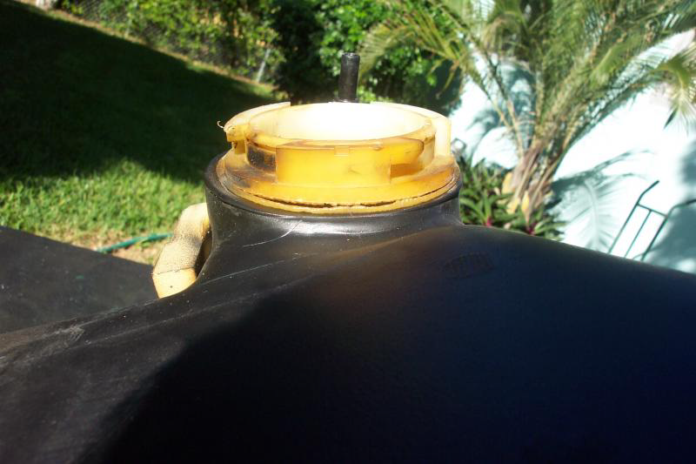

(8VETTE7, 8/15/10): By the time you can see the cracks you should long before have been able to smell fumes and/or see the puddles on the ground as you fill the tank. According to the information in the GM reports that 2004C5blackcoupe posted a page or so back, at a .010 opening the fumes are noticeable and by the time the crack is .020 there are leaks visible. Not sure I would put much stock into being able to see the cracks from a lift unless you already have leaking visible to the ground as you fill the tank.

(Chrohm, 8/15/10): Is there certain documents I should take with me to get them to pay for it?

(General Lee, 8/15/10): From the documents that are posted above it seems the fuel tank connector changed back to the 'proper' or 'correct' formula after the April date listed above in a document link. My build was in May 2004 and I’m wondering if my tank will not have any issues, that is if I’m understanding the information in the document.

(UM Rebel, 8/15/10):

Originally Posted by 2004c5blackcoupe
UM Rebel:
Did the NHTSA representative you spoke to tell you ALL 2004 c5's are affected?
Suspect lot number 2697 on 01/07/04 was 3,600 lbs mfgd.
suspect lot number 2637 on 09/30/03 was 3,000 lbs mfgd.
See page 148
http://nhthqnwws112.odi.nhtsa.dot.go...015-40764P.pdf
I could have misunderstood about "all" 2004's. I had a lot going on when he called. Mine was manufactured in 10/03 and I am sure he said, based on the VIN it fell into the "suspect window".

(2004c5blackcoupe, 8/15/10): Chrohm,
Copy the documents and memos in prior post. Show the dealer that this is a manufacture defect and they should be liable. Mention Small Claim Lawsuit...Get leak fixed before your car catches fire or worse. Take pictures and send the tank to NHTSA for recall investigation.
Please file safety complaint with NHTSA ASAP Thanks!
More NHTSA Documents at:
http://nhthqnwws112.odi.nhtsa.dot.go...romPublic=true

"By design, the right hand tank is mounted tightly to its surrounding surfaces. The left hand tank has a 12mm gap to its mounting surfaces that is filled with foam isolators. The purpose of the foam is to dampen noise related to fuel pump operation. This gap allows the LEFT HAND TANK TO MOVE MORE THAN THE RIGHT HAND TANK during driving maneuvers and as a result, THE LEFT HAND QUICK CONNECTOR EXPERIENCES MORE LOAD than the right hand. Additionally, since there is always more fuel in the left hand tank than right hand tank, even when both are full, THE LEFT HAND QUICK CONNECTOR WILL EXPERIENCE HIGHER LOADS."
Also, of the total warranty claims, the left hand fuel tanks were replaced 89% of the time vs. 11% for the right.
http://nhthqnwws112.odi.nhtsa.dot.go...015-40760P.pdf
see page 14
If the foam isolators compress over time then the left hand tank would move even more causing excessive stress on the connector eventually causing a crack/ failure/leak.
I believe this design is part of the problem in addition to defective connector.
Don't you guys think that the left hand tank should be more secure, perhaps strapped down or more foam to prevent movement? You can pull almost 1 g in a hard turn, not to mention 0-60 in four seconds! If so, then GM needs to do a re-design of the mounting of the left tank. Anyone?

(8/16/10) There are 49 fuel system complaints logged with the NHTSA ODI so far.
A copy of these complaints might convince your dealer to cover repair.
Go to:
http://www-odi.nhtsa.dot.gov/complaints/
search selected type: enter 2004, Chevrolet, Corvette, fuel system gasoline
If you want NHTSA to mandate a recall please enter a complaint to get investigation moving forward. PE10015 is a "preliminary investigation" at this point.

(ratmotortom, St. Marys, OH, 8/16/10): Read this !!!!!
#10150: Special Coverage Adjustment-Fuel Tank Quick Connector Leak - (Aug 13, 2010)
Subject: 10150 - Special Coverage Adjustment - Fuel Tank Quick Connector Leak
Models: 2004 Cadillac XLR
2004 Chevrolet Corvette
--------------------------------------------------------------------------------
Condition
Some 2004 model year Cadillac XLR and Chevrolet Corvette vehicles may have a fuel tank leak at the quick connectors that are used to link the left and right fuel tanks. The customer may notice a fuel odor while the vehicle is being refueled, driven, or after it is parked. If the leak becomes large enough, a small amount of fuel may be observed dripping on the ground. The leak may also result in a diagnostic code being set and the illumination of the Check Engine light on the instrument cluster.
Special Coverage Adjustment
This special coverage covers the condition described above for a period of 10 years or 100,000 miles (160,000 km), whichever occurs first, from the date the vehicle was originally placed in service, regardless of ownership.
Dealers are to replace the leaking fuel tank. The repairs will be made at no charge to the customer.
For vehicles covered by Vehicle Service Contracts, all eligible claims with repair orders on or after August 16, 2010, are covered by this special coverage and must be submitted using the labor operation codes provided with this bulletin. Claims with repair orders prior to August 16, 2010, must be submitted to the Service Contract provider.
Vehicles Involved
Involved are certain 2004 model year Cadillac XLR and Chevrolet Corvette vehicles built within the following VIN breakpoints:
Year
Divison
Model
From
Through
2004
Cadillac
XLR
45600796
45602844
2004
Chevrolet
Corvette
45110258
45125500
Important: Dealers are to confirm vehicle eligibility prior to beginning repairs by using the Investigate Vehicle History link on the Global Warranty Management application within GlobalConnect. Special Coverage Adjustments are displayed in the Applicable Warranties section.
Parts Information
Parts required to complete this special coverage are to be obtained from General Motors Customer Care and Aftersales (GMCC&A).
Part Number
Description
Qty/ Vehicle
25899601
Tank, Fuel (LH)
1 (If Required)
10337582
Tank, Fuel (RH)
1 (If Required)
89047640
Insulator, F/Tnk (LH)
1 (Required when replacing left fuel tank)
15223882*
Hose, Fuel Feed
1 (If Required)
10337583*
Pipe, Aux Fuel Feed & Rtn RR (LH)
1 (If Required)
10337581*
Pipe, Aux Fuel Feed & Rtn RR (RH)
I (If Required)
21008100**
Gasket, F/Pmp
1 (If Required)
* Less than 30% of vehicles requiring tank replacement will require this.
** Less than 25% of vehicles will require this.
Customer Notification
General Motors will notify customers of this special coverage on their vehicles (see copy of typical customer letter included with this bulletin - actual divisional letter may vary slightly).
Service Procedure
Determine if the left or right fuel tank is leaking. Refer to Fuel Tank Leak Test in SI for diagnostic information.
• If the left or right fuel tank is leaking, proceed to Step 2.
• If the fuel tanks are not leaking, no further action is required.
Remove the left or right fuel tank from the vehicle. Refer to Fuel Tank Replacement - Left Side or Fuel Tank Replacement - Right Side in SI.
Install the new fuel tank. Refer to Fuel Tank Replacement - Left Side or Fuel Tank Replacement - Right Side in SI.
Claim Information
1. Submit a claim using the table below.
Labor Code
Description
Labor Time
Net Item
T5787
Perform Diagnostics - No Tank Replacement Required
0.0-0.3
N/A
T5785
Replace One Fuel Tank
7.5
N/A
Add: Replace Both Fuel Tanks
2.0
Add: Diagnostic Time
0.0-0.3
T5786
Customer Reimbursement (not for use by US GM dealers)
0.2
*
* The amount identified in "Net Item" should represent the dollar amount reimbursed to the customer.
Customer Reimbursement - For US
All customer requests for reimbursement for previous repairs for the special coverage condition will be handled by the Customer Assistance Center, not by dealers.
A General Motors Customer Reimbursement Procedure and Claim Form is included with the customer letter.
Important: Refer to the GM Service Policies and Procedures Manual, section 6.1.12, for specific procedures regarding customer reimbursement and the form.
Customer Reimbursement - For Canada and Export
Customer requests for reimbursement of previously paid repairs to correct the condition described in this bulletin are to be submitted to the dealer prior to or by August 31, 2011. Repairs must have occurred within the 10 years of the date the vehicle was originally placed in service, or 160,000 kilometers, whichever occurs first.
When a customer requests reimbursement, they must provide the following:
- Proof of ownership at time of repair.
- Original paid receipt confirming the amount of unreimbursed repair expense(s) (including Service Contract deductibles), a description of the repair, and the person or entity performing the repair.
If the work was done by someone other than a GM dealership, the amount of reimbursement will be limited to the amount that the repair would have cost GM to have it completed by a GM dealership.
August 2010
Dear General Motors Customer:
As the owner of a 2004 Cadillac XLR or Chevrolet Corvette, your satisfaction with our product is very important to us.
This letter is intended to make you aware that some 2004 Cadillac XLR and Chevrolet Corvette vehicles may have a fuel tank leak at the quick connectors that are used to link the left and right fuel tanks. The customer may notice a fuel odor while the vehicle is being refueled, driven, or after it is parked. If the leak becomes large enough, a small amount of fuel may be observed dripping on the ground. The leak may also result in a diagnostic code being set and the illumination of the Check Engine light on the instrument cluster.
Do not take your vehicle to your GM dealer as a result of this letter unless you believe that your vehicle has the condition as described above.
What We Have Done: General Motors is providing owners with additional protection for the fuel tank connectors. If this condition occurs on your 2004 model year Cadillac XLR or Chevrolet Corvette vehicle within 10 years of the date your vehicle was originally placed in service or 100,000 miles (160,000 km), whichever occurs first, the condition will be repaired for you at no charge. Diagnosis or repair for conditions other than the condition described above is not covered under this special coverage program.
What You Should Do: Repairs and adjustments qualifying under this special coverage must be performed by a General Motors dealer. You may want to contact your GM dealer to find out how long they will need to have your vehicle so that you may schedule the appointment at a time that is convenient for you. This will also allow your dealer to order parts if they are not already in stock. Keep this letter with your other important glove box literature for future reference.
Reimbursement: The enclosed form explains what reimbursement is available and how to request reimbursement if you have paid for repairs for the special coverage condition. Your request for reimbursement, including the information and documents mentioned on the enclosed form, must be received by GM by August 31, 2011.

(rebelheart, 8/16/10): This is great news except none of the local dealers have clue about this letter or extended warranty.

(8VETTE7, 8/16/10): GREAT NEWS.
Since the letter is dated August 13, 2010 I expect it will take a little time before the local dealers will get around to reading and observing the policy.
But it does look like GM has stepped up to the plate at least for a portion of the C5 gas tank problems.
Thanks to all those that took the time to file the NHTSA documents! Without your efforts NHTSA would never have been involved and I have no doubt that without pressure from them GM would have been content to do absolutely nothing.

(rebelheart, 8/16/10): After talking with the service manager (not the advisor) and giving him the subject number, he was able to look it up. I have an appointment to have my car checked tomorrow morning. I will keep you posted as he says he knows the parts will probably not be available.

(8VETTE7, 8/16/10):

Originally Posted by 2004c5blackcoupe
Outstanding News! Looks like GM reads the Corvette Forum and decided to finally fix a six yr old problem. What about 2003 models that had defective connectors produced on 9/30/03?
Is that the correct date? Seems like on 9/30/03 GM would have been producing 2004 cars, no?

(ratmotortom, 8/16/10):

Originally Posted by Jims Z06
So I take my car to the Dealership, show them this letter, and then to confirm it that it's true the dealership contacts who?
Actually the first thing you do is take the car to your dealer and have him confirm that your car has a leak as described in the letter. If the leak is confirmed, the procedure is very simple. He runs the service letter I posted here and fixes the car.

(2004c5blackcoupe, 8/16/10):

Originally Posted by 8VETTE7
I read that link. I'm referring to your post that says:
"What about 2003 models that had defective connectors produced on 9/30/03?"
My point is that 2003 models were NOT being produced 9/30/03. Something doesn't jive in your model year and the Sept 2003 date.
Good Point, 2004 production started June 30, 2003.
The special coverage would then cover cars PRODUCED October 8, 2003 (VIN 110202) starting with 110258 through cars PRODUCED March 18, 2004 (VIN 125399) starting with 125500, all of which are 2004 MODELS.
http://www.c5registry.com/MembersOnl...2004/index.htm

(zphase, Texas, 8/17/10): Thanks ratmotortom. I called GM Customer Assistance Center and they called my dealership to confirm that I had the tank replaced. My dealership called me and told me that I will be getting a full refund within 10 days.

(rebelheart, 8/17/10): I had my car in this morning to be checked. They have to order parts, which I expected, but are replacing both tanks, the crossover and assorted gaskets and hoses......NO CHARGE,NO HASSLE!

(8VETTE7, 8/17/10):

Originally Posted by Worthington
So I'm curious. My VIN falls within range. A week ago (and it lasted about a week) I had a very strong fuel odor coming from the rear left. The last week it's been gone though. Never had a leak I noticed.
Dealership is telling me they will change to determine if it's part of this, if it is no cost, otherwise I pay for the diagnostic.
It's only $100 but I'm thinking I should probably wait until I smell it again -thoughts?
If you have read through this thread you will have noticed that this problem primarily is noticeable when you FILL the tank. Go fill the tank and see what happens.
Beginning to think this might have been better as a recall rather than a voluntary thing where the dealers can make up their own rules as they go along.

(2004c5blackcoupe, 8/17/10): "Its only $100"
GM should pay for diagnostic, Dealer is trying to make you pay for their defect. If you smell fuel, more than likely you have a leak...get it fixed as soon as possible.

(Chrohm, 8/17/10):

Originally Posted by UM Rebel
I'm not sure I would drive it even to the dealer to get it fixed. Think would get it towed!
I thought about it. I told him there was a service fix that just came out for it and he kind of smirked and goes, "do you have a warranty?" I just told him it should be covered. I can tell I may run into some trouble with the dealer, but hopefully when he searches it, it'll pop up.

(rebelheart, 8/17/10): The repair gives .3 to diagnose, print the subject 10150 and hand it to him. Though I think you really need to go to another dealership that is more honest. Also contact GM and let them know this dealer is extorting money from it's customers for warranty repairs. Most of the time you will only smell fuel vapors when you have over a half tank and fuel is transferred to the right tank through the crossover tube.

(8VETTE7, 8/17/10):

Originally Posted by SCM_Crash
OK, I have a 2003 Z06, and haven't had this issue yet, although my VIN is after they started making this change.
I know this recall isn't for my car (correct?) but I wouldn't want to take my car to the dealership at all. Back in the days when I was bringing my car in to the dealer, I was running into the issue that random things on my car were breaking at a very predictable rate. After I stopped bringing my car to the dealer and fixing things myself, things stopped breaking on my car.
The last thing I want is to start this cycle again. I know from talking to someone that used to work for the dealerships that they purposely screwed things up on cars that had nothing to do with the work being performed so the car would keep coming in. Is GM going to let us bring the cars into our own mechanics (assuming they're certified)? I'd rather pay for the tanks myself and install them than let another dealership screw up my car.
This "Special Coverage Adjustment" is NOT for 2003 vehicles. It is for a limited set of 2004 C5's in the VIN range 45110258 - 45125500. So as it currently stands you need not worry about the dealer doing anything to/for your car.

(2004c5blackcoupe, 8/17/10): No response to previous post so I will bring it up once again for any thoughts concerning excessive left fuel tank movement and it being held in by FOAM isolators contributing to this fuel tank problem. The root cause being defective connectors.
"By design, the right hand tank is mounted tightly to its surrounding surfaces. The left hand tank has a 12mm gap to its mounting surfaces that is filled with foam isolators. The purpose of the foam is to dampen noise related to fuel pump operation. This gap allows the LEFT HAND TANK TO MOVE MORE THAN THE RIGHT HAND TANK during driving maneuvers and as a result, THE LEFT HAND QUICK CONNECTOR EXPERIENCES MORE LOAD than the right hand. Additionally, since there is always more fuel in the left hand tank than right hand tank, even when both are full, THE LEFT HAND QUICK CONNECTOR WILL EXPERIENCE HIGHER LOADS."
Also, of the total warranty claims, the left hand fuel tanks were replaced 89% of the time vs. 11% for the right.
http://nhthqnwws112.odi.nhtsa.dot.go...015-40760P.pdf
see page 14
If the foam isolators compress over time then the left hand tank would move even more causing excessive stress on the connector eventually causing a crack/failure /leak.
I believe this design is part of the problem in addition to defective connector.
Don't you guys think that the left hand tank should be more secure, perhaps strapped down or more foam to prevent movement? You can pull almost 1 g in a hard turn, not to mention 0-60 in 4 seconds!
Anyone?

(CatCam, 8/17/10): Makes perfect sense to me. If the crossover pipe were flexible made of thick walled rubber it would not be much of an issue, but the rigid composite connector with a "loose" tank is a recipe for failure.

(SMC_Crash, 8/18/10):

Originally Posted by 8VETTE7
This "Special Coverage Adjustment" is NOT for 2003 vehicles. It is for a limited set of 2004 C5's in the VIN range 45110258 - 45125500. So as it currently stands you need not worry about the dealer doing anything to/for your car.
Specifically, I was more or less asking the "what if" for if GM was forced to handle 2003 cars with this tank issue, and/or I hypothetically had a 2004 that was within the VIN range, would I be able to go to my own mechanic.

(rebelheart, 8/18/10): Warranty repairs must be done at an authorized dealership.
I am thinking that if the tanks were built properly (strong enough) in the first place, slight movement would not be an issue. Those cars outside of the VIN range have no problems.

(Chrohm, 8/19/10): The DOT got back with me today, the representative seemed very adamant about making sure the situation is investigated and taken care of if needed. Those who had the repair, how long was your car in the shop?

(zphase, 8/19/10): 2.5 days. They didn't have a fuel tank in stock so they over-nighted one from Houston.

(8VETTE7, 8/19/10):

Originally Posted by 04 commemorative
45110837......but no problem....yet....so what should I do?
Wait and see what happens. Mine is in the range as well and no problems as yet. They are extending the coverage on cars in the problem VIN range for 10 years from first date of service or 100,000 mile which ever comes first.
Originally Posted by Chrohm
Stay tuned for a recall.
We can hope there will be a recall but since GM has voluntarily (more or less) stepped up to the plate for the known problem range of vehicles, it is unlikely that NHTSA will force a recall in my opinion.

Originally Posted by dadsturn
Now, the million dollar questions is, what is GM going to reimburse the ones that had it repaired already?
They state that they are going to reimburse the cost that GM would be out of. What about the labor costs and parts cost that we had to pay to get them fixed? Even at the dealerships, our cost will be higher than what GM states is their cost.
If you read the letter carefully it states the "if the work was done by someone other than a GM dealership" they limit the reimbursement to what it would have cost GM to have it completed by a GM dealership. I see no statement of limiting the reimbursement if a GM dealership did the work.

(Chrohm, 8/20/10): Dealership called me today after three days of it being in the shop to tell me it was the fuel fill neck that cracked and not the connector problem and that I will have to pay approx $2200 to replace the same parts they would be replacing anyway. I’m pretty angry right now. Any ideas? Or am I just out of luck?

(8VETTE7, 8/20/10): If it were me I would want to go down to the dealer, look at the said problem (take your camera) and validate the issue and then call GM Customer Service. If it is not the problem in the letter I would be opening a case with NHTSA as I am a firm believer that no part of the fuel tank/fuel fill system should fail and let fumes or gas out.
Good luck on this. Please keep us posted on what you find. Pictures would be nice.

(Chrohm, 8/20/10): Went down there, he said I could take pictures but it would take a while to drag everything back out - he was very fine with it however.
I told him if he just calls me Monday I'll take off work and come over. He said he is used to taking photos and video and will e-mail it to me. So due to my work schedule I think I'm going to let him do that.
Also, he said it really looks like I just bottomed out (my car is lowered) and the force of the tank moved the filler neck enough to crack it up high somehow - and then cause the fuel to run back down the neck and under the tank looking like a leak from where the connectors are approximately.
In that case, maybe I can turn it into insurance. Either way I'm screwed and guess this was just a coincidence that this happened when the service exception came out. Bummer for me.

(UM Rebel, 8/23/10): Took mine into Service Chevrolet this morning. Couple of hours later service manager called and said that I had the problem described in the service bulletin, that the parts have been ordered and should be in tomorrow. So far, hassle free!

(rebelheart, 8/25/10): I would have to ask them to prove it was impact damage as the tanks are pretty well shielded by the mufflers.

(UM Rebel, 8/25/10): Fixed! No cost, No hassle. Thanks to everyone who posted here and reported to NHTSA. Thanks also to Service Chevrolet for courteous and prompt service.
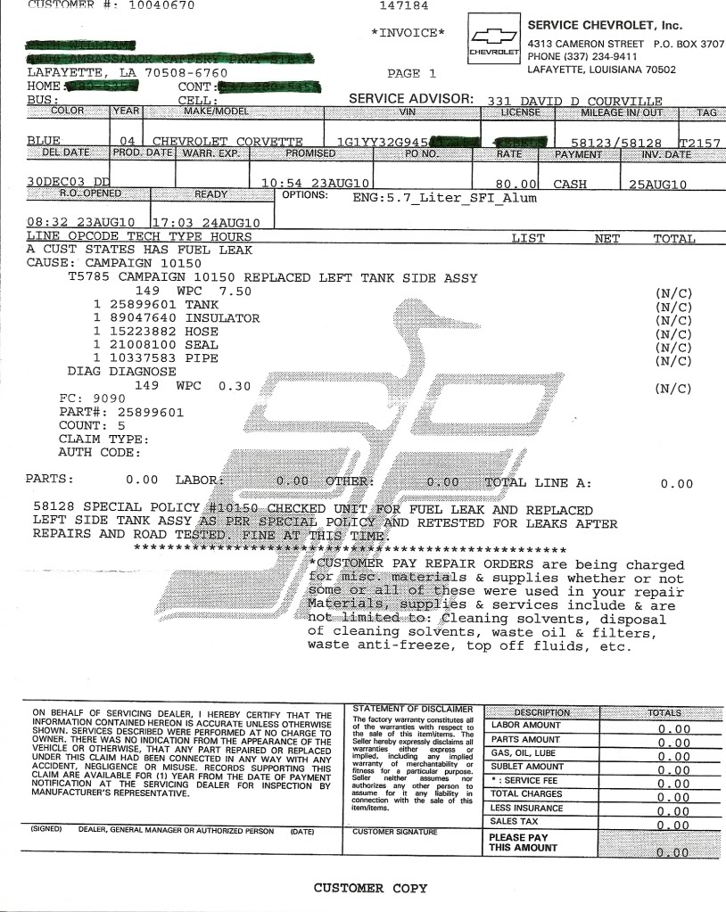

(Jims Z06, 8/25/10): Fantastic news! I had my Corvette in yesterday for diagnostics, they said I was covered under Special Policy #10150. They are replacing both tanks, fuel-crossover and seals. Ordered parts yesterday. It will be nice after driving it for 10 months and having to calculate at each gas stop how much to get with out going over 5/8 tank (and always looking under the car on the driver's side to watch for spewing fuel...a little unnerving to say the least).

(8VETTE7, 8/25/10):

Originally Posted by cor24vette
Posted by ratmotortom -
http://forums.corvetteforum.com/show....php?t=2660531. But what about the late 2003's with the same problem?
Back on August 9, 2010 "2004c5blackcoupe" began posting links to information that is available on the NHTSA web site. Look here and read the several posts and links starting with:
http://forums.corvetteforum.com/c5-g...smells-21.html
If you read through all the information available in the respective links, the only "smoking gun" for this fuel tank leak situation is for a limited group of 2004 cars. I'm not saying that there are not other cars that experience a similar issue. Just that so far GM has chosen to only recognize a group of 2004 cars that had tanks assembled with suspect adhesive used to cement the bungs to the tanks. I firmly believe the pressure needs to continue to be applied to GM through NHTSA for all cars that have this tank system and experience problems. If your car is one of those and you have experienced a leak, please file a complaint with NHTSA so the process can continue and hopefully a recall can be forced.

(rebelheart, 8/26/10): My dealer also had my parts in a day ,perhaps GM's stock is now running low. It makes me feel proud that after I opened the complaint with the NHTSA that everyone stepped up and reported their own issues. Now, so many owners have their cars repaired and safe once again, or have had their hard earned cash returned to them. A really great job guys! I really think that the NHTSA did its job on this one also despite the nay sayers!

(2004c5blackcoupe, 8/27/10): Chrohm,
If your "filler neck connector" to tank cracked, and your vehicle is within the VIN range, good chance the "fill neck connector" is defective as well. Save tank get it to NHTSA, open "new investigation" so they can determine if "fill neck connectors" were also manufactured at same time as crossover connectors. All are made from same olefin nylon material.
Call John Abbot NHTSA to discuss problem.
202 366-5221
NHTSA PE10015 is still listed as OPEN.
There really should be a RECALL for the entire DEFECTIVE tank.

(2004c5blackcoupe, 8/28/10):

Originally Posted by Bobd207s
I have a 2001 with 74k miles and just this week got a very strong smell of gas after filling the car. The smell is gone now that the tank is no longer completely filled. Any suggestions what I should do to fix this?
First remove left rear fender liner and check that filler hose clamps are tight.
Is fuel leaking on ground after fill? Check crossover connectors for any sign of leak/cracked connector. 2001 is not in the VIN range for Special Adjustment Recall.

(rebelheart, 8/28/10): I got my car back after three days (I told them I was in no hurry). Two new tanks and a crossover tube, a full tank of gas (I brought it in on empty) and a freshly washed car. Best of all, no sign of leakage and no cost to me!

(8VETTE7, 8/30/10):

Originally Posted by dadsturn
Tell me if I am reading this right. I have to wait until GM sends me a letter, with the reimbursement information? Or is there a short cut to this being finished?
I would print out the letter from this link:
http://nhthqnwws111.odi.nhtsa.dot.go...0015-41488.pdf
Then call the GM Customer Service 800 number and ask them for help getting the reimbursement.

(rebelheart, 8/30/10): You can actually bring your papers to any Chevy dealer and tell them to look up bulletin 10150 and they should be able to take care of it for you.

(Chrohm, 9/2/10): Update:
After two weeks and three days, they finally got a new tank shipped in. I went in when he took it off and noticed it wasn't the part he said was leaking- it was actually the connector where it fits into the left tank leaking around the connector.
I told him it's covered in special coverage and I guess he finally took the time to look into what I initially told him what it was after raising a little hell at the dealership. He called me today to tell me he's over nighting the return line that they didn't order initially and that GM is paying for all of it.
Finally a victory. Now if I could only get GM to reimburse me for half a car payment during the time I haven't had my car.

(rnengnr, 9/2/10): I just got my reimbursement letter and its going to feel good to get that 2000 bucks back.

(Chrohm, 9/3/10): Here's what mine looks like:
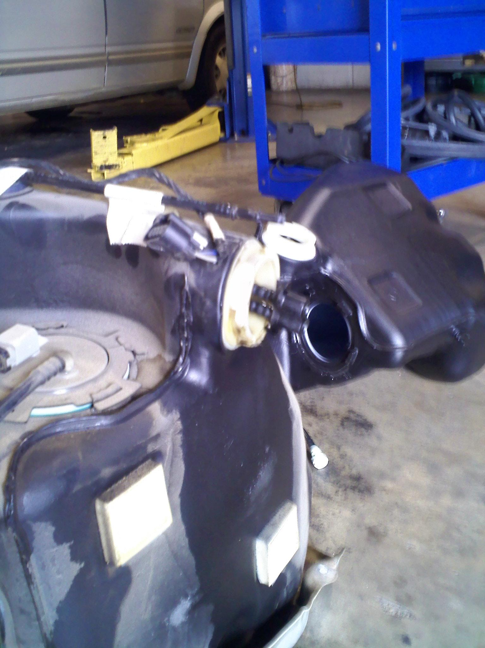
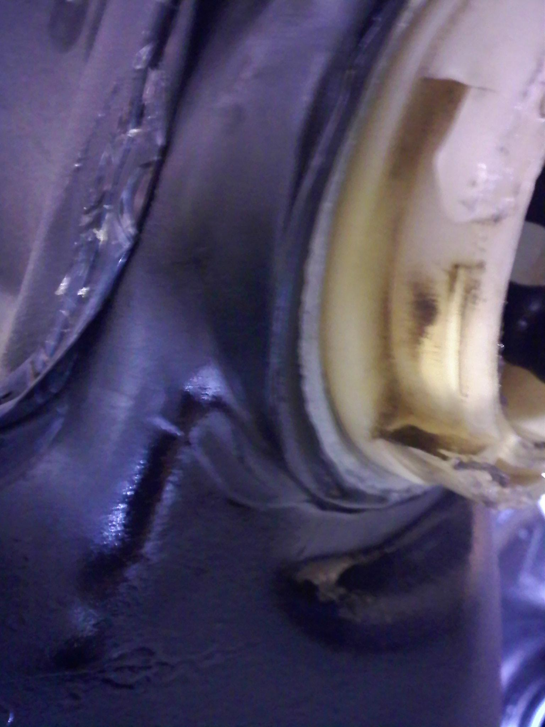
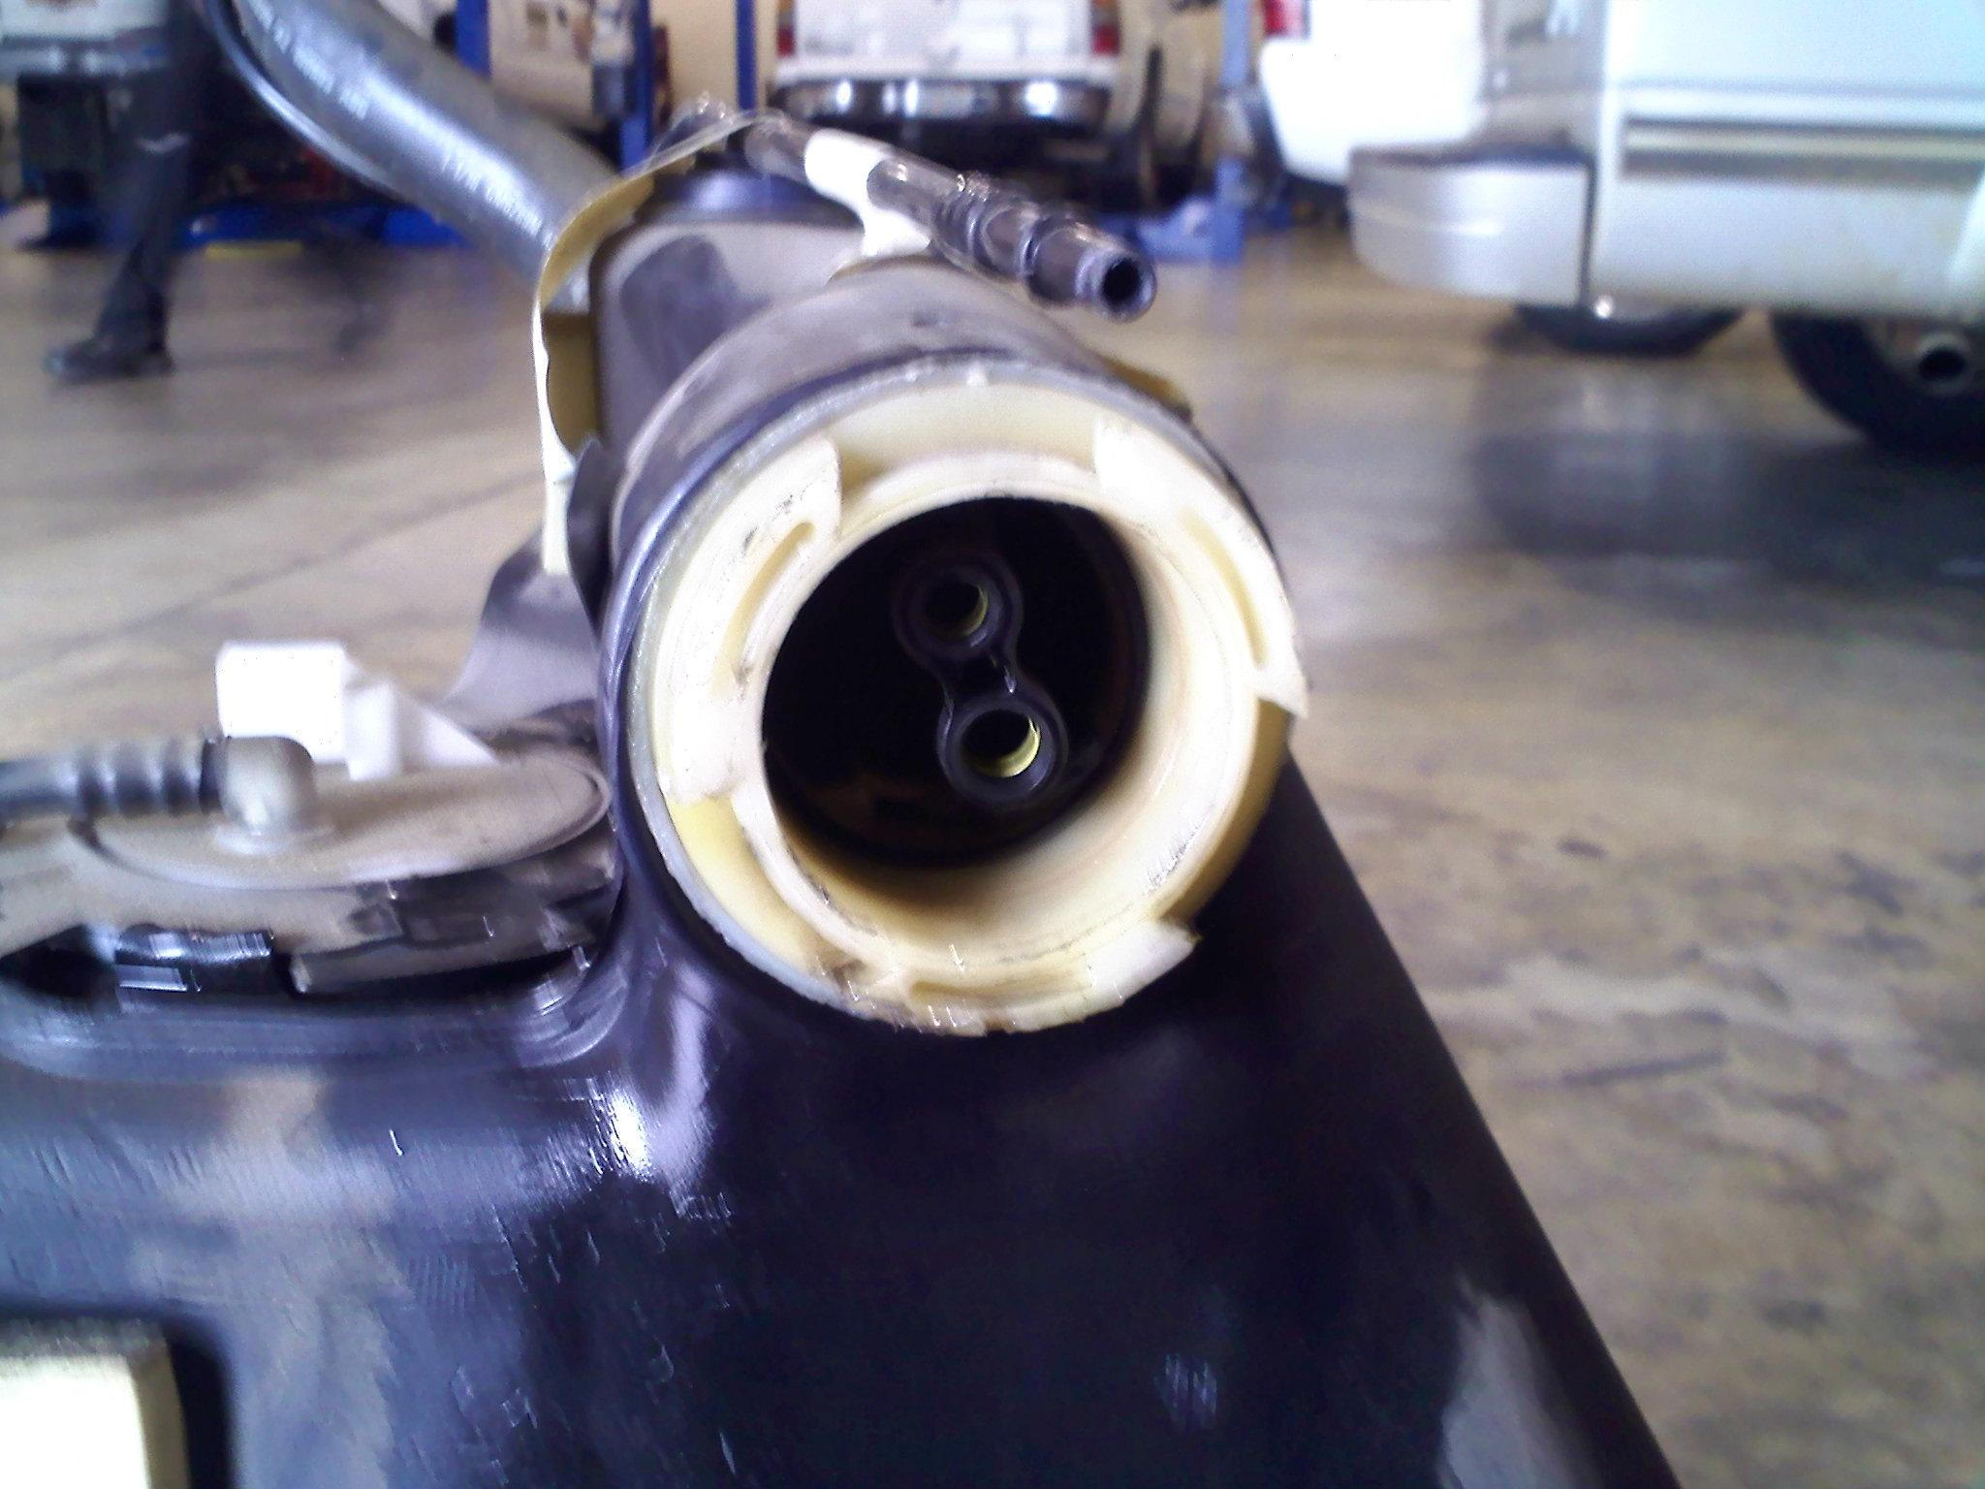

(tlove32, California, 9/4/10): This issue has reared its ugly head on my 2004 Z06 - I had a puddle when filling up today, and it just so happens that I got my letter from GM. I'm calling my trusted Corvette dealership on Monday to get mine fixed. Stay tuned.

(2004c5blackcoupe, 9/7/10): Just wondering if anyone with a 2004 has, or has had a leaking fuel tank that is out side of the VIN range? If so, then more vehicles need to be included in this "Special Adjustment.” Better yet, a recall by NHTSA, so there is no time limit for low mileage cars.
45110258 October 8, 2003
45125500 March 18, 2004

(8VETTE7, 9/7/10):

Originally Posted by Rohan
Why is this only on 2004 cars? What makes them different? When I fill completely up on my 2001 Z06 I get a gassy smell for a while. Then once I burn off a couple gallons the smell goes away. Could this be the vent? I'm really hoping it's not the crossover tube.
For starters the later 2003 and all 2004 C5's got a completely new gas tank system (RPO FFS). That system among many other changes has a stainless steel cross over pipe vs. the rubber pipe on the early C5's.
Start reading at post #419 on this link and you will see why the SMOKING GUN is currently for a limited VIN range of 2004 cars:
http://forums.corvetteforum.com/c5-g...smells-21.html

(tonylukes3, Florida, 9/7/10): Well, the dealer found a gas stain between the tanks and said better safe than sorry so they're ordering two new tanks and parts. I'll report back when it's all fixed, but the car is home for now.

(Chrohm, 9/7/10): After 2.5 weeks I got my baby back, unwashed - I can tell it even sat out in the rain some more, and charged me for my oil change.
Last time I go to that dealer. I love how he kept acting like he did me a favor by calling GM and getting them to cover the leak like it was my fault in the first place.

(geoc, Henderson, KY, 9/7/10): I got a letter from Chevrolet last week about this problem. It says they will fix anything with this problem and reimburse you if you have made repairs up to 8-31-2011. I smell gas sometime but haven't noticed a leak. Taking mine in tomorrow though so they can check it anyway.

(04 commemorative, New Jersey, 9/9/10): Well, mine checked out OK. No leaking. But they said I am covered for another 80K or until 2014 whichever comes first, so I should be OK.

(Chrohm, 9/12/10): So how long will the replacement parts last?

(rebelheart, 9/13/10): Since they aren’t from the bad batch of tanks, I would think the issue would not happen again.

(UM Rebel, 9/14/10): Took mine in Monday August 23. Got it back Wednesday August 25.

(2004c5blackcoupe, 9/14/10): PE 10-015 NHTSA Investigation Closed 09-10-10
NHTSA Action Number : PE10015 NHTSA Recall Campaign Number : N/A
Make / Models : Model/Build Years:
CHEVROLET / CORVETTE 2004
Manufacturer : GENERAL MOTORS CORP.
Component :
FUEL SYSTEM, GASOLINE
FUEL SYSTEM, GASOLINE DELIVERY: HOSES, LINES/PIPING, AND FITTINGS
FUEL SYSTEM, GASOLINE:STORAGE
FUEL SYSTEM, GASOLINE:STORAGE:TANK ASSEMBLY
FUEL SYSTEM, GASOLINE:STORAGE:TANK ASSEMBLY:FILLER PIPE AND CAP
Date Investigation Opened : May 12, 2010
Date Investigation Closed : September 10, 2010
Summary:
In its June 30, 2010 response to ODI's Information Request letter, General Motors (GM) identified the leak source as cracks in either the fuel tank cross-over tube quick connector (connector) and/or the "hot-plate" weld joint of the connector to the tank. The root causes are attributed to errors in connector material processing, variations in the welding process, and high stresses placed on the driver's side connector during vehicle use. GM also identified the scope of the subject vehicles involved to be those produced from approximately October 22, 2003 through March 19, 2004. GM does not believe the cracks represent an unreasonable risk to motor vehicle safety based on factors that include; low rate of fuel leaking to the ground, detectable fuel odor, the cracks are at the top of the tank, leaks are detectable during refueling, small quantities of fuel that leaks out, and no associated property damage or personal injury claims. On August 13, 2010, GM issued a "Special Coverage Adjustment" to remedy fuel tank quick connector leaks and extend the warranty for this issue to 10 years or 100,000 miles in certain 2004 Chevrolet Corvette and Cadillac XLR vehicles. Vehicle owners will be notified by mail of the adjustment and will also be entitled to reimbursement for previously paid repairs covered under the adjustment. (See file for, SERVICE BULLETIN 10150: SPECIAL COVERAGE ADJUSTMENT-FUEL TANK QUICK CONNECTOR LEAK). The closing of this investigation does not constitute a finding by NHTSA that a safety-related defect does not exist. The agency reserves the right to take further action if warranted by the circumstances.

NHTSA Closing Document/Action/Summary Information
http://nhthqnwws112.odi.nhtsa.dot.go...10015-7965.PDF
Here is the kicker: "GM does not believe the cracks represent an unreasonable risk to motor vehicle safety."
No recall at this point, but a “Special Service Adjustment."

So instead of a RECALL, GM will fix your vehicle only IF it is leaking. That’ great unless you fill your tank, park it in your garage, go to sleep and your house catches on fire! If your 2004 is within the VIN range but is not leaking you are driving a potential time bomb. Without a recall, then after 2014, or 100,000 mi. you are out of luck.
GM admits there is a defect, but won't issue a recall. We will only fix it if it is leaking!
Looks like NHTSA dropped the ball on this one.
NHTSA Investigator: John Abbott
NHTSA Reviewer: Scott Yon
NHTSA Approver: Richard Boyd
Corvette on fire.
http://www.youtube.com/watch?v=l0l3A...eature=related

(rebelheart, 9/15/10): While the bulletin helps out many people, I do think a recall would have been better since this is a major safety issue. GM probably made a deal with the NHTSA to avoid a very costly recall and will repair affected cars in a "need to" basis, even though they tried to hide it and knew there were bad tanks out there. Just keep an eye on your Corvettes guys!

(rnengnr, 9/15/10): Looks like you can just drive in and the service computer will identify it and you will get it done without a letter.
Originally Posted by chucks
My car is in the time frame to be covered, but I have never received a letter. Is there any one at GM I can contact?

So, now this is interesting. My service invoice show the tank as the only part replaced in my repair. I wonder if the additional components need to be changed as part of this "special coverage adjustment?"
By the way guys, my fuel pump started making a small whine after this work was done.
Originally Posted by 2004c5blackcoupe
PE 10-015 NHTSA Investigation Closed 09-10-10
NHTSA Action Number : PE10015 NHTSA Recall Campaign Number : N/A
Make / Models : Model/Build Years:
CHEVROLET / CORVETTE 2004
Manufacturer : GENERAL MOTORS CORP.
Component :
FUEL SYSTEM, GASOLINE
FUEL SYSTEM, GASOLINE DELIVERY:HOSES, LINES/PIPING, AND FITTINGS
FUEL SYSTEM, GASOLINE:STORAGE
FUEL SYSTEM, GASOLINE:STORAGE:TANK ASSEMBLY
FUEL SYSTEM, GASOLINE:STORAGE:TANK ASSEMBLY:FILLER PIPE AND CAP
Date Investigation Opened : May 12, 2010
Date Investigation Closed : September 10, 2010
Summary:
In its June 30, 2010 response to ODI's Information Request letter, General Motors (GM) identified the leak source as cracks in either the fuel tank cross-over tube quick connector (connector) and/or the "hot-plate" weld joint of the connector to the tank. The root causes are attributed to errors in connector material processing, variations in the welding process, and high stresses placed on the driver's side connector during vehicle use. GM also identified the scope of the subject vehicles involved to be those produced from approximately October 22, 2003 through March 19, 2004. GM does not believe the cracks represent an unreasonable risk to motor vehicle safety based on factors that include; low rate of fuel leaking to the ground, detectable fuel odor, the cracks are at the top of the tank, leaks are detectable during refueling, small quantities of fuel that leaks out, and no associated property damage or personal injury claims. On August 13, 2010, GM issued a "Special Coverage Adjustment" to remedy fuel tank quick connector leaks and extend the warranty for this issue to 10 years or 100,000 miles in certain 2004 Chevrolet Corvette and Cadillac XLR vehicles. Vehicle owners will be notified by mail of the adjustment and will also be entitled to reimbursement for previously paid repairs covered under the adjustment. (See file for, SERVICE BULLETIN 10150: SPECIAL COVERAGE ADJUSTMENT-FUEL TANK QUICK CONNECTOR LEAK). The closing of this investigation does not constitute a finding by NHTSA that a safety-related defect does not exist. The agency reserves the right to take further action if warranted by the circumstances.

(2004c5blackcoupe, 9/15/10):

Originally Posted by chucks
My car is in the time frame to be covered, but I have never received a letter. Is there any one at GM I can contact?
This is the Official GM Special Coverage Adjustment Doc. #10150. If your vehicle is within the VIN range and you smell fuel or there is a leak take a copy of this in and get your car repaired. http://nhthqnwws111.odi.nhtsa.dot.go...0015-41488.pdf

(8VETTE7, 9/15/10):

Originally Posted by chucks
My car is in the time frame to be covered, but I have never received a letter. Is there any one at GM I can contact?
Did you mean time range or VIN range? VIN range is:
45110258-45125500
If your VIN is in the above range and you have the symptoms don't wait for the letter, just take it to the dealership. The dealer can verify the GM campaign on their system. It's "10150 - Special Coverage Adjustment - Fuel Tank Quick Connector Leak" if you want to help them out.

(rebelheart, 9/16/10): If you smell fuel when you fill your car, that is the time to take it in and show them. The proper way to test the tank is with a smoke machine or vacuum leak down test.

(rnengnr, 9/17/10): Commemorative, that is exactly what the dealer told me and they recommended I buy a cap. I did,, it did not fix the issue, obviously mine was leaking.
If it still smells take it to another dealer if possible and tell them what the other dealer did and reference the notice that is so kindly posted many times on the thread.

Originally Posted by 04 commemorative
I did smell gasoline when I filled up. Took the Corvette and letter to dealer. They checked it out and said all was fine - gas cap was loose! Gas cap was not loose! But I am covered until 2014 but as tlc0706 said, what about those of us that do not use our Corvette a lot? 2004 with almost 20K.

(2004c5blackcoupe): Anyone able to open the PE10015 NHTSA document file which was just submitted on the NHTSA site? This is a large 56866 KB zip file. Should contain a lot of new information.
http://nhthqnwws112.odi.nhtsa.dot.go...romPublic=true
INRD-PE10015-40762P.zip GM 6/30/2010 ATTACHMENT 1, Q_03_REQUEST NUMBER TWO DATA [ACCESS DATEBASE] 56866

(rtpilot, 9/26/10): The document is a Microsoft Office ACCESS document. It contains reports of complaints and repairs to the mentioned Corvette models. Also included in the reports are PDF's from the dealership repair departments of the findings. The document size is over 1,324,000,000 bytes. LARGE and boring.

Originally Posted by 2004c5blackcoupe
Thanks for taking a look at this new information, sorry it was boring. Hoping there might be some VIN numbers outside of the special adjustment fix-it range that also had leaks so as to include more vehicles. How were you able to open the file?
I downloaded the file (a zip file)...unzipped it and opened it with MS Office Access. That is the only way to view. It only has VIN's for cars already serviced. There are 226 field reports on the problem. Hope that helps. By the way, they do included VIN's of the cars serviced.

(ONE BMF, 9/28/10): GM is covering it under warranty now --I have a 2004 Z06. Any 2004 with less than 100k miles is covered - dealer just put in new driver’s side tank/crossover tubes/lines/seals etc. It has leaked since last December when they had it all apart for a new fuel pump, and then refused to take care of the issue. I told them if my car burns up then so will this dealership and then some. Guess GM heard -- they better fix their " MARQUEE " car or what are they telling the world! I wonder how many caught fire before they wised up. You don't even have to rear end it like the old Pintos to get them to blow up - just fill your tank/tanks ,and take a drive. Get it fixed free - they should be covering more than 2004's in my opinion.

(2004c5blackcoupe, 9/28/10): Are you saying ALL 2004's are covered?
The Special Coverage Adjustment is for vehicles with VIN range 45110258 through 45125500 or cars manufactured October 22, 2003 through March 19, 2004.
http://nhthqnwws111.odi.nhtsa.dot.go...0015-41488.pdf

(ONE BMF, 10/2/10): I was told all 2004.

(garage-ghost, Pennsylvania, 2/12/11):

Originally Posted by Bobd207s
I am considering purchasing a 2004 Coupe whose VIN falls into the cars that might have this problem. I have read almost all of this thread but would like to get some clarity as to what the letter means. Can you only get repairs before there is a problem or do you have to wait for the car to start to leak gas or smell of gas? The car I'm looking at has 13k miles so I assume that it qualifies. The car is in California and I'm in NH. Would any dealer across the country fix the problem or does it have to be repaired in California? Sorry if these questions are dumb but it's a lot of money and 3,000 miles away. Any other help/suggestions is really appreciated
You have to wait for the car to start to leak gas or smell of gas.

(cdes, 2/12/11): My problem was only noticeable after fill-ups. Once the fuel level drops, leaks and odors won't be noticeable. Get the car you are looking at onto a lift and examine the area above the gas tank for leaks. This will determine if leaks have occurred. Chevy corrected my problem and so far, so good.

(8VETTE7, 2/12/11):

Originally Posted by Bobd207s
I am considering purchasing a 2004 Coupe whose VIN falls into the cars that might have this problem. I have read almost all of this thread but would like to get some clarity as to what the letter means. Can you only get repairs before there is a problem or do you have to wait for the car to start to leak gas or smell of gas? The problem symptoms MUST have started to occur before GM will pay for the repair. The car I'm looking at has 13k miles so I assume that it qualifies. The car is in California and I'm in NH. Would any dealer across the country fix the problem or does it have to be repaired in California? Any dealer can repair the problem once the symptoms have started. Sorry if these questions are dumb but it's a lot of money and 3,000 miles away. Any other help/suggestions is really appreciated. The extended coverage from GM is good only until the car reaches 100,000 miles or until the car has been in service for 10 years which ever occurs first.
See responses in BLUE above.

(6GenVettes, 5/8/11): So we are still left to wonder what about the 2003's that have the special RPO Code FFS for those who own C5's produced > VIN 14929 built November 22, 2002 and after? That's when the change to this new system was introduced. It was said back in Jan 2003 that you were.
"driving the Corvette of the future. Those smart engineers @ GM were able to improve on theC5 (future C6) fuel system with newly designed tanks, quieter fuel pumps and greatly improved fuel gauge measuring system."
Source: Official C5 Registry.

(8VETTE7, 5/8/11): If you start reading at this link and post #419
http://forums.corvetteforum.com/c5-g...smells-21.html
You will see that the problem is NOT with the FFS fuel system. Rather there were a batch of bad tanks made in late 2003 that were installed in the 2004 Corvette C5 and 2004 Caddy XLR from late October 2003 through late January 2004. The posts and links in those posts identify the cause of the failure and the resulting tanks made with the potentially defective parts. I say potentially defective with a smile. According to GM not all the vehicles in the VIN range have had the symptoms appear and GM is banking on those vehicles not having the symptoms. In my biased estimation (my VIN is in the subject range but as yet does not have the symptoms) the vehicles in the VIN range should be the subject of a recall where ALL would have their tanks replaced. But GM and our supposed protector (NHTSA) appear to have gotten in bed together, in my opinion.
The FFS tanks installed prior to the specified VIN numbers in this link:
http://nhthqnwws111.odi.nhtsa.dot.go...0015-41488.pdf
and those installed after the specified VINS are not a part of this "Special Coverage Adjustment." That leaves all the 2003 FFS tanks and the remaining 2004 and later FFS tanks. For what it is worth the same tank design is in the C6.

(GK, Union City, CA, 8/31/11): I'd like to add I received the notification from GM via mail last August. I re-read it today and it says 10 years or 100K, whichever comes first.
However, a few paragraphs below it also states:
Reimbursement: The enclosed form explains what reimbursement is available and how to request reimbursement if you have paid for repairs for the special coverage condition. Your request for reimbursement, including the information and documents mentioned on the enclosed form, must be received by GM by August 31, 2011.
So, what happens to someone of they submit a request for reimbursement after today -- August 31, 2011? Is it 10 years/100K or not?

(Dave concrete, New York, 2/22/12): I just had my 2004 repaired by a dealer 100% free and even got a new fuel pump free. At first the dealer acted like they never heard of the problem - then when I gave them the action number they changed. This is a quick repair. I dropped my car off at 9:30 am. At 10:30 I got the call confirming the repair is needed which will include new driver’s side tank and crossover tube plus little parts and they won't have them until the following morning. The following day I popped in at 11:30 - parts just arrived I talk with the tech and he had not started yet. At 4 pm I get a call car is complete. Free. This tech happens to be a 20 year veteran Corvette mechanic and he’s done a few of these.

(mrx_33k, Alamo, TX, 3/12/12): Dave - how did you get them to replace the fuel pump for free? My dealer is wanting to charge me because it’s not on the bulletin. Did yours need replacing or did they just replace it because they were already there?

(8VETTE7, 7/20/12):

Originally Posted by SS2001SS
Ok, my VIN falls in this range but I have not noticed the problem yet. I have only filled up three or four times since buying the car. What's the chance I have one of these bad tanks or whatever, and what is involved in the repair if it shows up after this 'warranty' is expired?
It's an unknown whether your tank will fail or not. I also own one of the vehicles in the VIN range.
If it were to fail within the allowed mile or time paramaters set by GM (10 years from first day of service or 100,000 miles which ever occurs first) you simply present your self and car to a GM dealership and identify that your car is within the range for free repair. They can verify that from the GM bulletins. I carry a copy of the letter I received from GM in my glove box to aid in the issue should it happen.

Originally Posted by SS2001SS
So the repair is a new crossover tube or whole tank assembly? Is the C6 Z06 tanks a direct replacement? Thanks for the info. How many miles on yours? I have 75k now.
Repair is a new driver’s side tank and crossover tube. Apparently the passenger side tank doesn't fail. The bung to which the crossover tube is attached usually cracks at the tank. The same fuel system was carried into the C6 model. As far as I know the tanks are the same in all the C6 models and the Cadillac XLR. Began mid year 2003 for the C5. My car is at 28K so time will expire before mileage for me unless it fails before the end of 2014.

