To my C5 Corvette Friends,
I’ve decided against making them. Mainly I don’t have the time and I have a day job!
Here are the complete instructions to make one. With pictures no less. As with any job you undertake, If you hurry the job, you’ll probably mess up.
Take your time, don’t get in a hurry, and you should be fine.
I’ve built a couple of them, and it takes about 3-4 hours to get the bends just right. YOU CAN DO IT!!.
When you are finished, you will have the satisfaction that YOU DID IT, and It was done right.

- Cut piece a piece of metal Use something about the same thickness as automotive fender metal. 2-3/4” L X 5/8” wide.
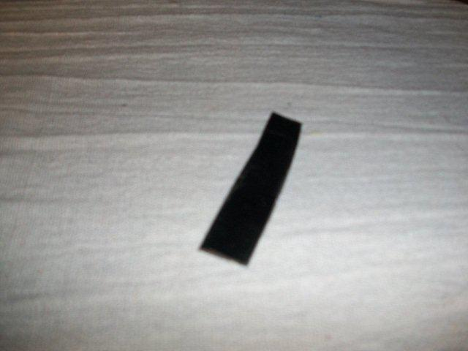

- Scribe a line 3/8th inch across one end of the metal strip
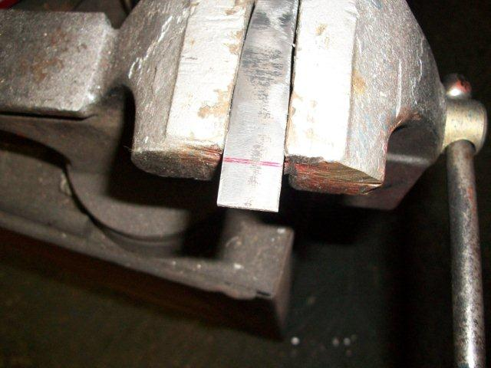

- Leave about a ¼ “ tongue in the center as shown. Use a cut-off wheel (or Dremel Moto tool with large cut-off wheel like me) To cut off the red parts shown.
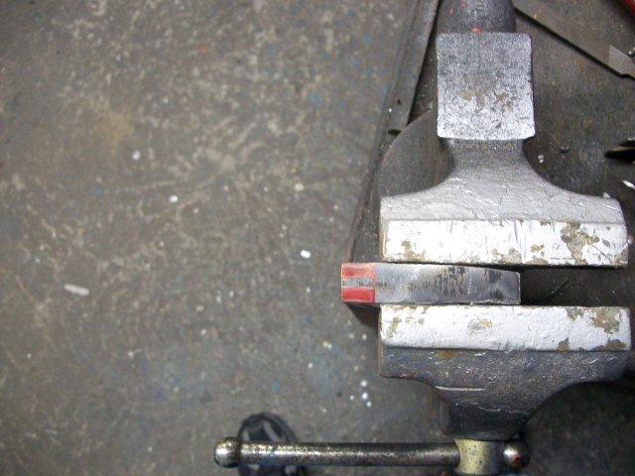

- When you get done, you should have something like this.
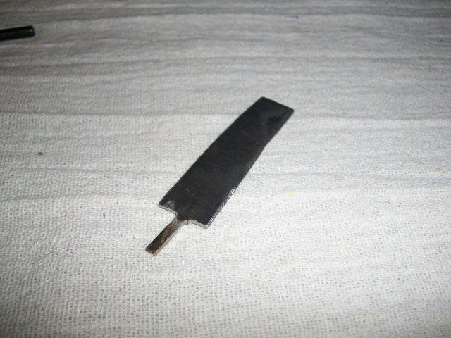

- Now, take a 3/16th X 1” roll pin. It dosen’t have to be longer because you’ll cut off some of it later.
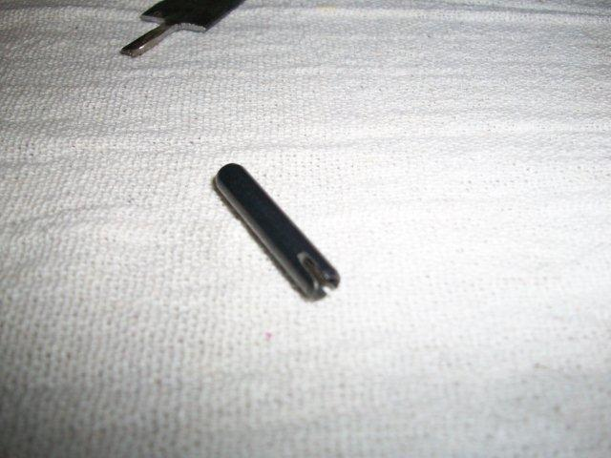

- Take the pin and notch about a 3/16 slot opposite the full length slot .

- Depending on the roll pin, you may have to widen the factory groove with a dremel tool. I had to do this one.
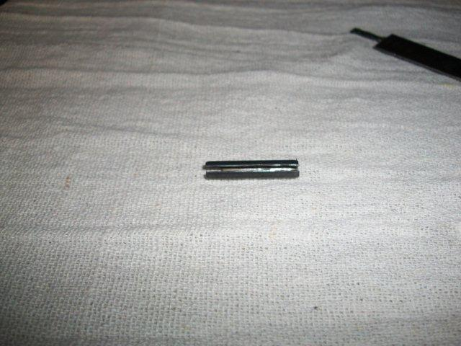

- Now take the roll pin and push it onto the tongue you made on the metal strip. This is what you will have.
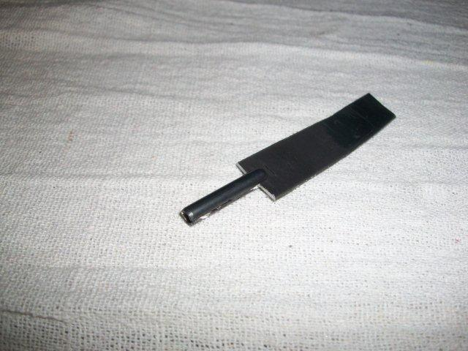

- I soldered the roll pin to the metal strip, but I assume a good quality epoxy will suffice.

- Chop the Roll pin ½” from the edge of the paddle as shown.

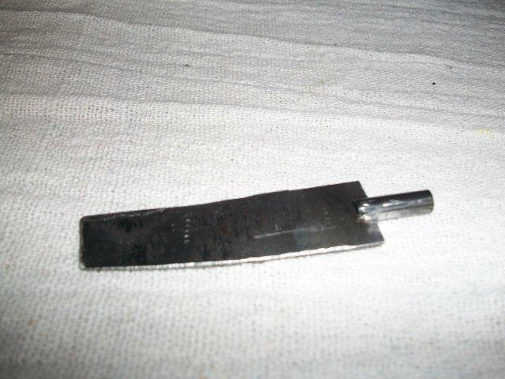

- Make your first bend 3/16” from the end of the roll pin.
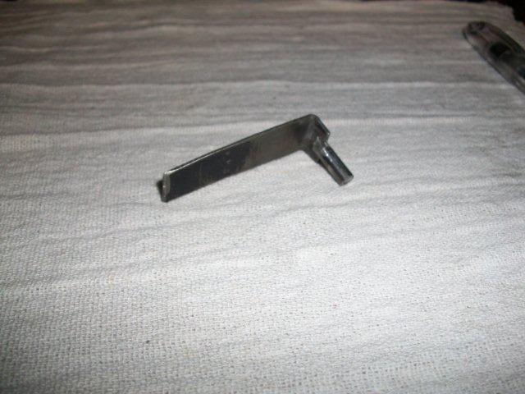

- Make the next bend ¾” away from the first bend.
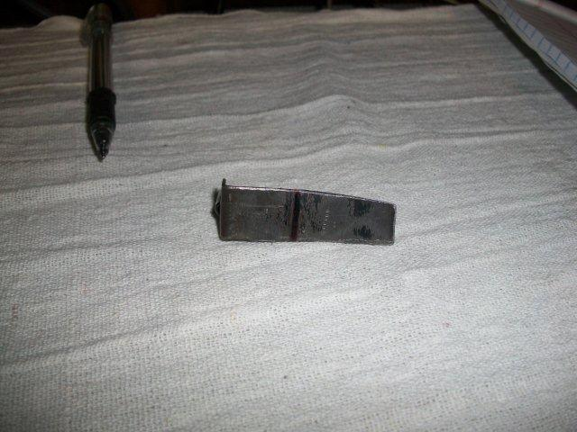

- You will need to make this bend as shown. Use the old indicator as a guide, otherwise Eyeball it as close as you can to the angle of the white plastic backing.
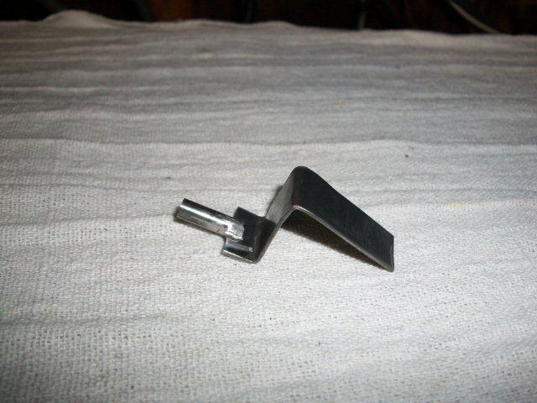

- Notch and bend the bottom as shown. These ears will align the indicator.
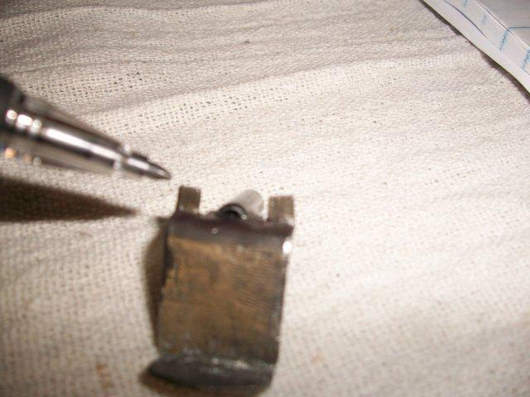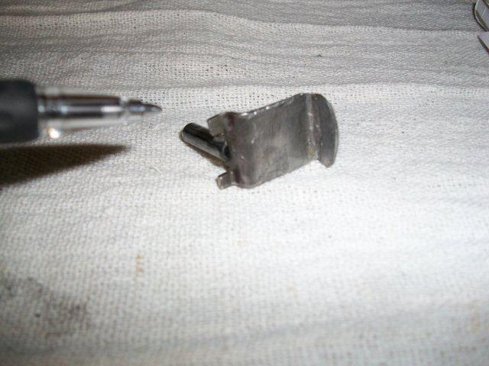

- Chop off and round off the top corners as shown. This will prevent binding.I’m talking about the top 2 corners. This will prevent the top from binding with the PRND321 Cover.
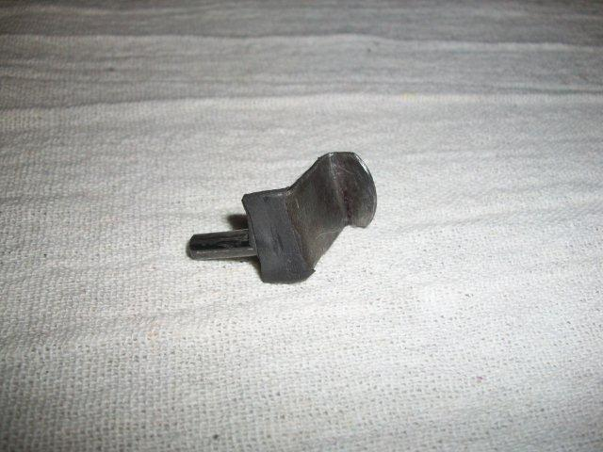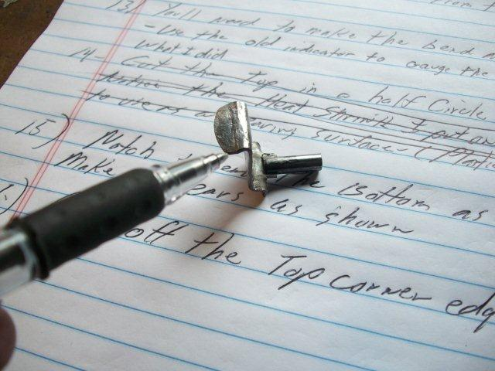

- Here it is in place.
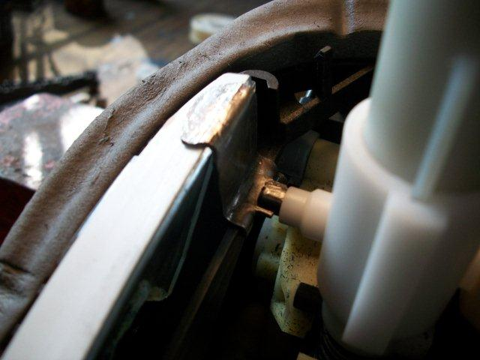

- Run it up to P and down to “1”. You will need to trim the edge so it does not bind on the cover.

- Here it is in place. Painted. Krylon Chevy Orange!, Of course!
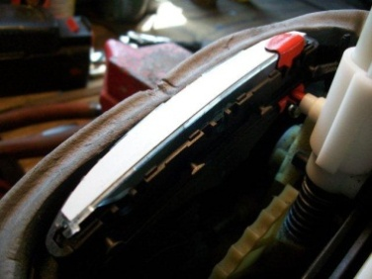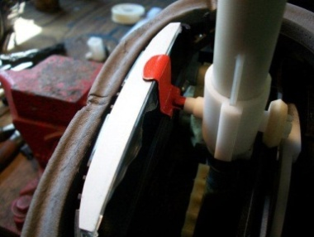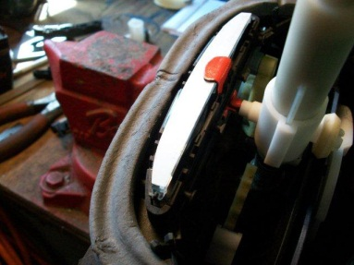
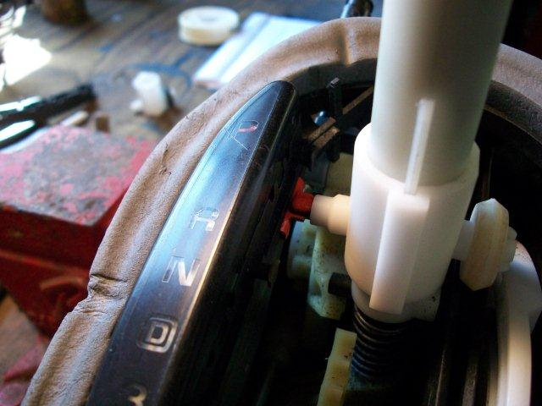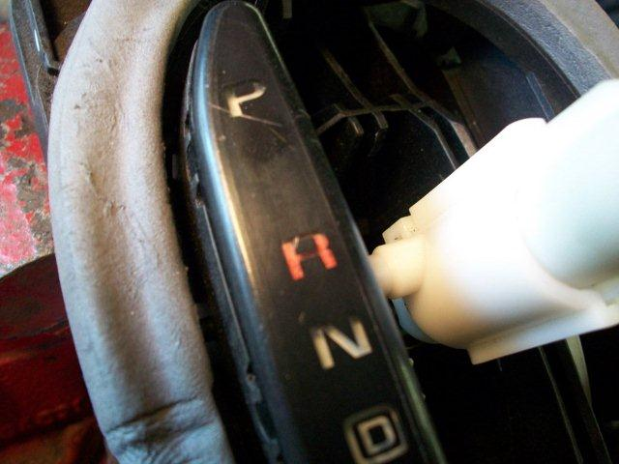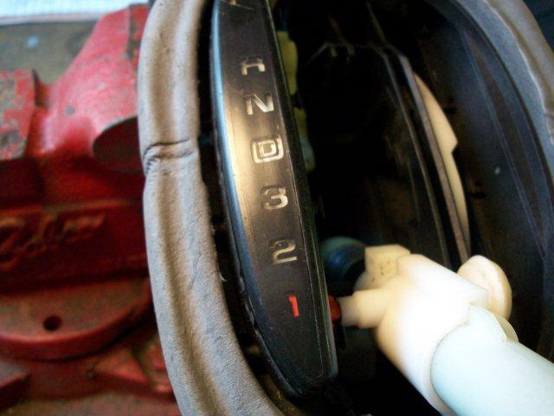

Take your time good luck!

Celarriviere

