Front Suspension Position Sensor Trim Height Learn
“The front suspension position sensor trim height learn should be performed any time a B152 Suspension Position Sensor is removed or replaced, or if the K218 Front Suspension Leveling/Lifting Hydraulic Power Pack Module is replaced.”

Note that there are left and right control arm mounted positions sensors with those exact names. The left side is called a “ B152 Front Suspension Automatic Forward Lighting Position Sensor”. The right side is called “B152 Front Suspension 4 Corner Leveling System Position Sensor”.

From the manual:
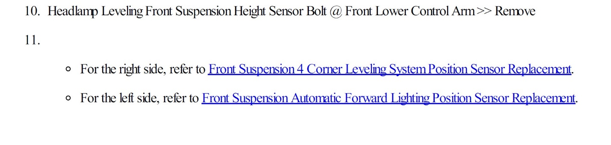”
End from the manual.

Elsewhere, it appears that these two sensors, the left and right, may both have a role in headlight
positioning, as follows from the manual:

“
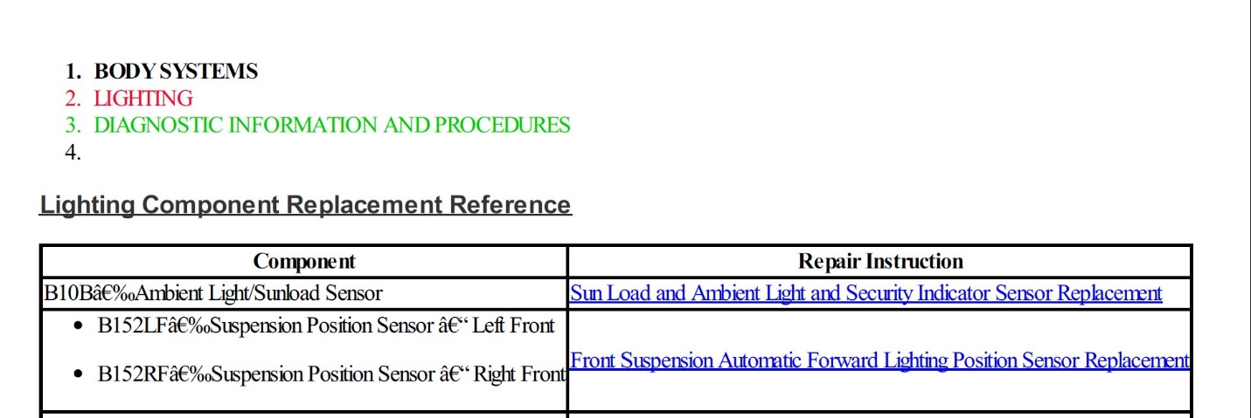” End from the manual.
In any case, it appears that the learn process refers to these two B152 Suspension Position Sensors that affect headlight aiming and might have another role in the Front Lift system.

Here are illustrations of those sensors.
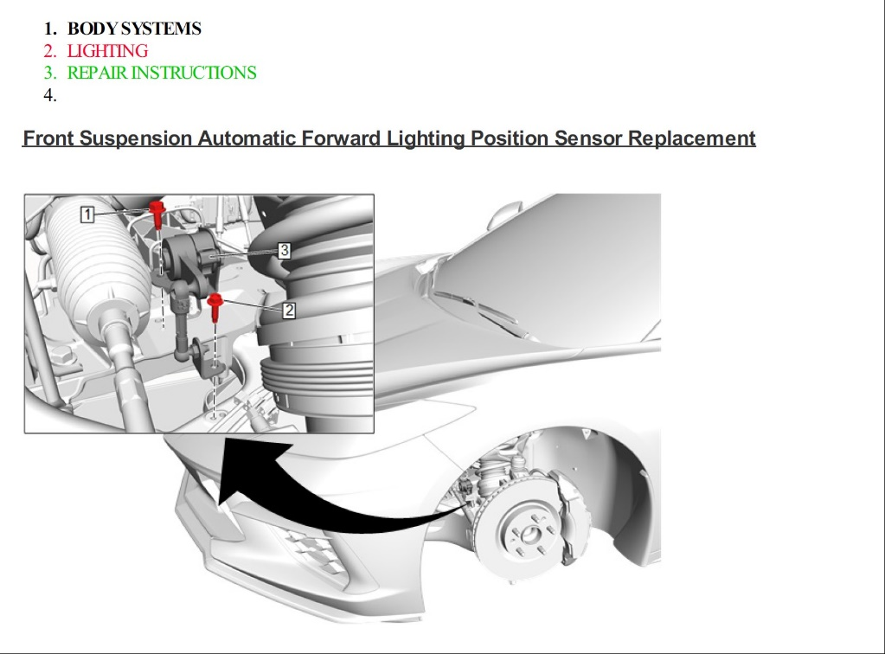
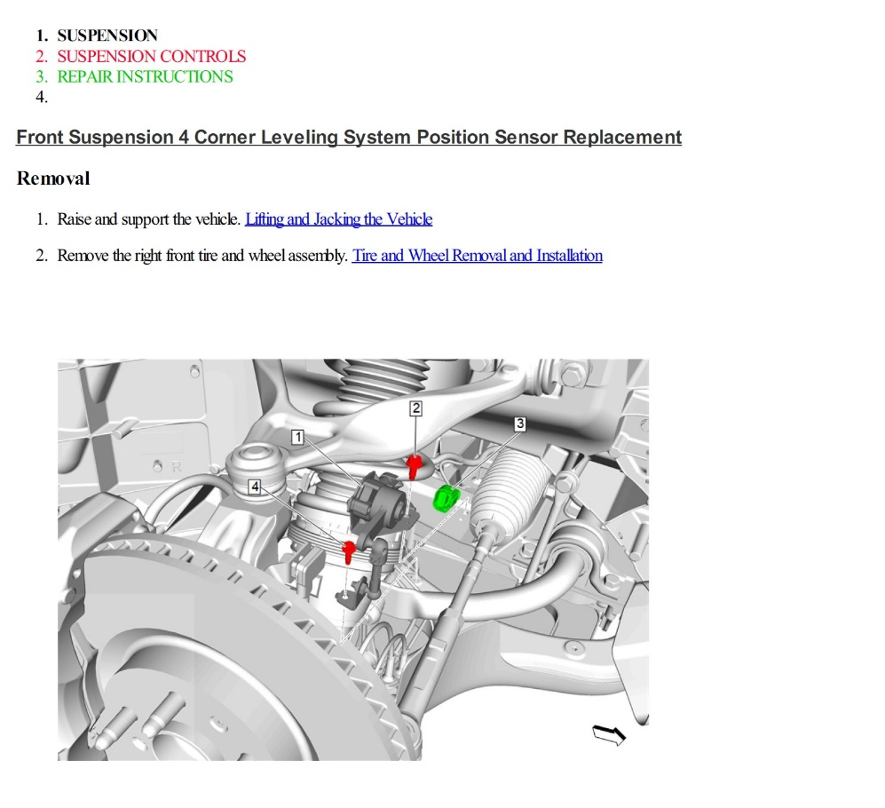

There are two other suspension positions sensors mentioned that sound similar, but use a different prefix in the name, and they are referred to as Strut Mounted Position Sensors.
They are referred to as B11LF Front Suspension 4 Corner Leveling System Position Sensor Left Front and B11RF Front Suspension 4 Corner Leveling System Position Sensor Right Front. They have their own DCTs associated with them. The distinction between the strut mounted sensors and control arm mount sensors is specifically called out in the manual. From the manual:
“
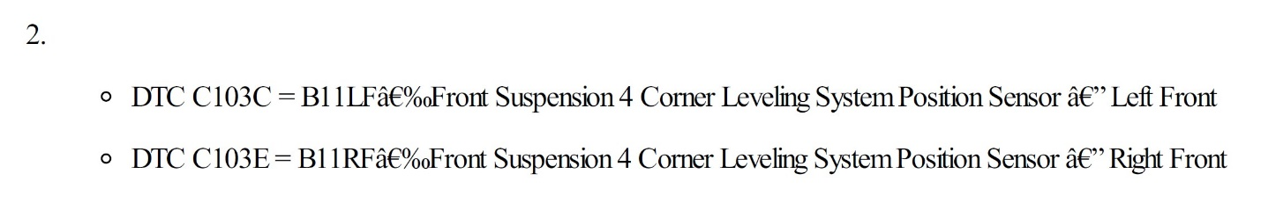
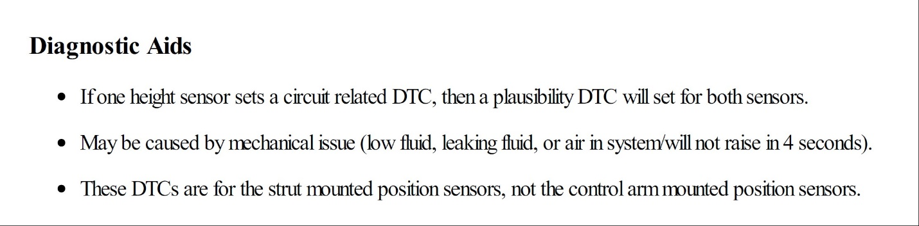” End from the manual.
In addition to the “front suspension position sensor trim height learn” procedure, which is executed from a scan tool, I also found references to calibration, programming and set up related to these functions. These, however, refer to “control module references” which list certain procedures to be performed when a module or component is replaced. From the manual: “
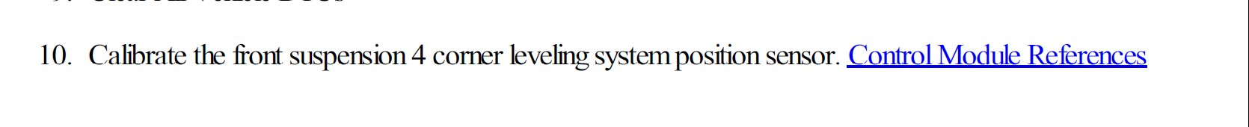
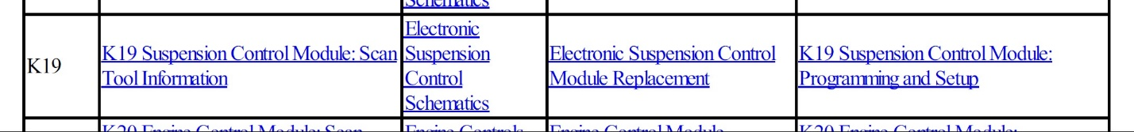
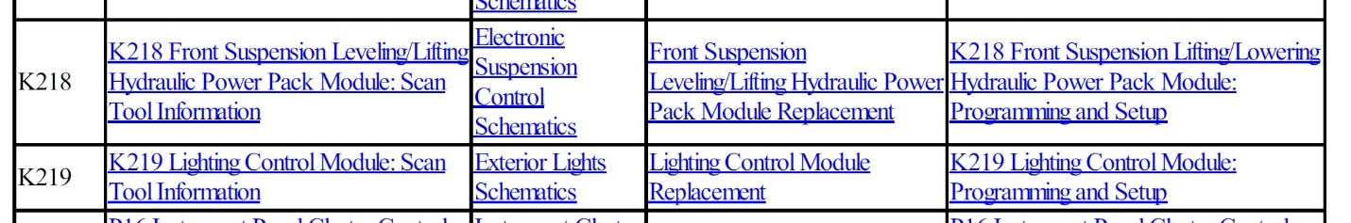” End from the manual.
So, bottom line, the learn function appears to address the control arm mounted B152 suspension sensors. What do they do? It appears they have a role in the headlight leveling. And apparently a role in the Front Suspension 4 Corner Leveling System – whatever that means. When I searched on that term, it was only discussed in the context of the Front Lift System. Again, I found no evidence that it directly affects ride and handling. The manual does not describe everything, and as pointed out by RKCRLR, there are many interactions in the system, so its possible that issues with these sensors could also affect other systems. The schematics show that all the data from the sensors go to the same modules, so it is all shared.

