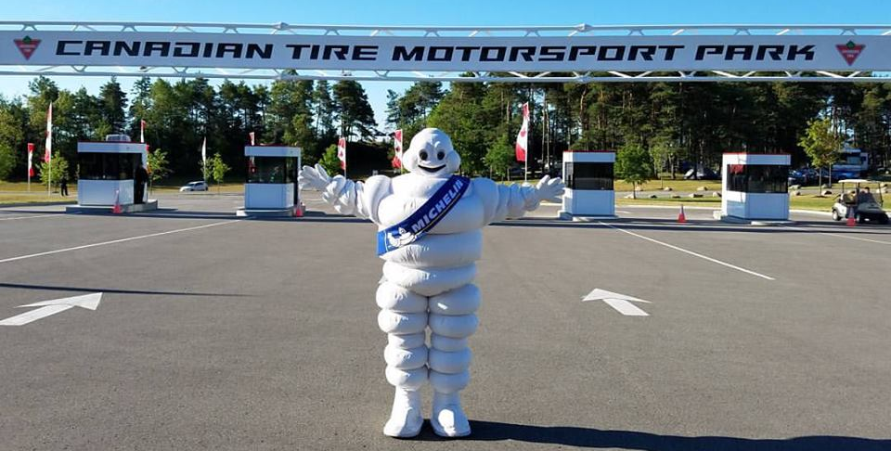
The IMSA Weathertech Race at Canadian Tire Motorsport Park is quickly approaching. Do you have your tickets?

The Weathertech SportsCar Championship featuring world class drivers piloting the globe's top marques such as Acura, Aston Martin, Audi, BMW, Corvette, Cadillac, Ferrari, Ford, Mazda, Nissan and Porsche will make their only Canadian appearance on July 4-7. Also in action over our four-day event are the IMSA Michelin Pilot Challenge and IMSA Prototype Challenge Series.
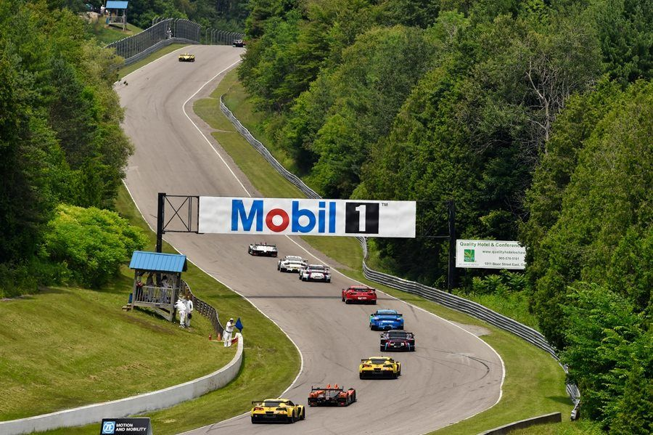
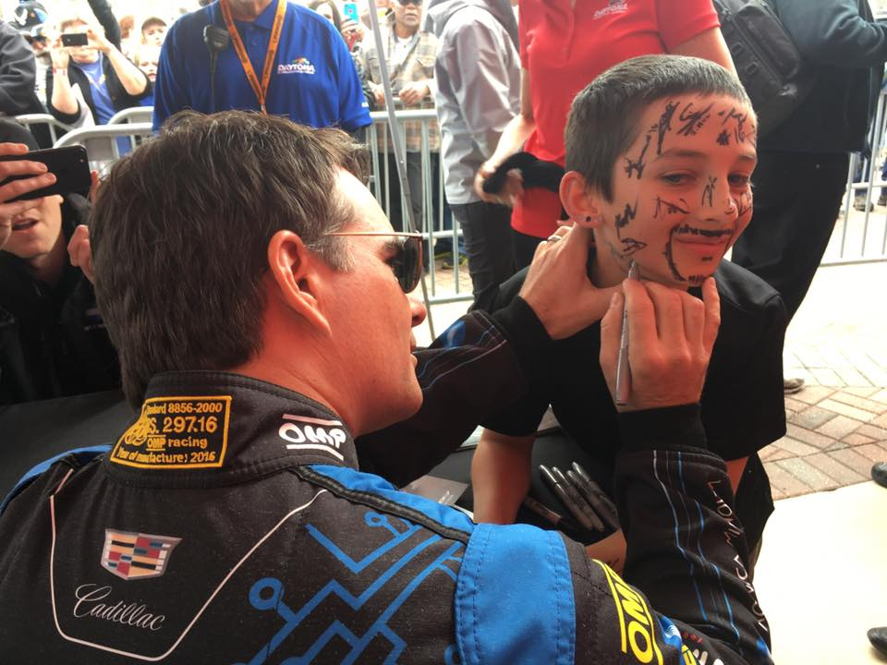
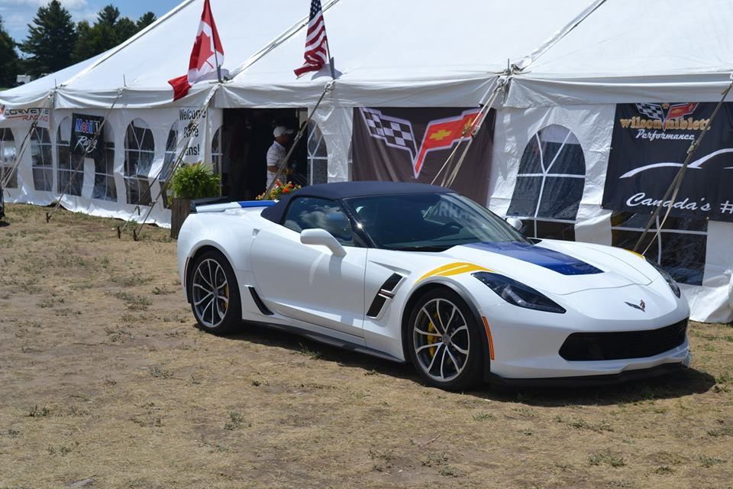
The Corvette Corral includes a trackside VIP-style area. Join other Corvette enthusiasts at the most exciting social gathering of the summer.
Your Corvette Corral Ticket includes:
• 4-day admission to the Mobil 1 SportsCar Grand Prix
• Access to a private tented area and parking in Corner 8 - Friday to Sunday
• Appearances and Tech talks, private autograph session, giveaways
• A chance to drive your Corvette around Canadian Tire Motorsport Park in a parade lap
• Sunday BBQ Lunch

Buy your Corvette Corral tickets online:
https://canadiantiremotorsportpark.com/products/mobil-1-sportscar-grand-prix?variant=2283497193481

Operation Motorsport Needs Your Assistance

In addition to our regular activities in the Corvette Corral, we will also hold a silent auction on Saturday to benefit Operation Motorsport. Their mission is to engage, through Motorsports opportunities, ill, injured and wounded Service Members and disabled Veterans, affected by military service, leading to aiding in their recovery and rehabilitation. Several of our corral volunteers are also volunteers with OpMo and have seen the great work this non-profit is doing within the race community but they can use our assistance to raise awareness and funds to send U.S. and Canadian participants to the track, and pay for their food and lodging.

***If you have any Corvette memorabilia you would like to donate for either the silent or live auction please contact me: janetpolasek@cogeco.ca

Operation Motorsport Swag Available for Pre-Order/Sale

We will also have a number of items available to show your support for a donation to Operation Mosport. Please send me an email if you are interested in any of these items in order for us to order in advance of Watkins Glen and CTMP. Some items are limited quantities.

Support bands $10 Operation Motorsport postcards $25 CAD

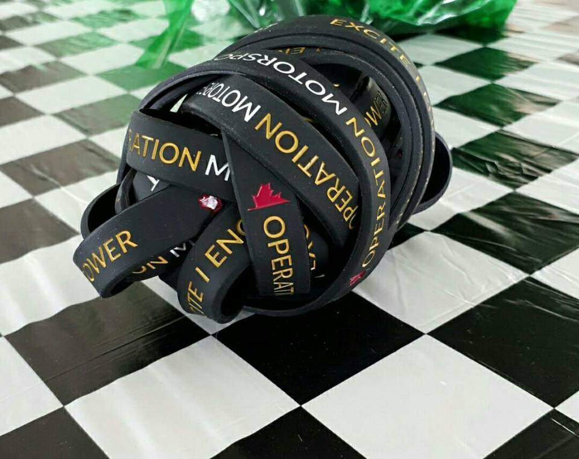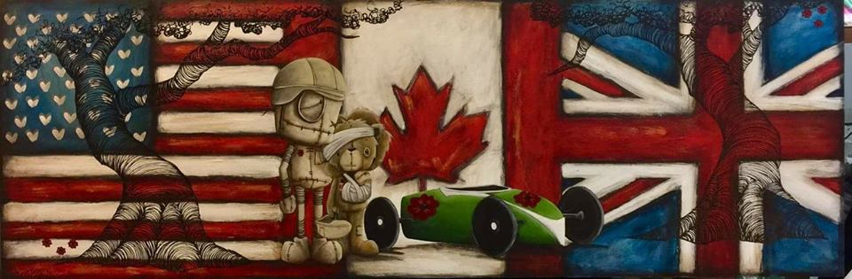

Luggage Tags – great for your luggage, camera bag, golf cart keys
Choice of red or black .. or order one of each
$20 CAD

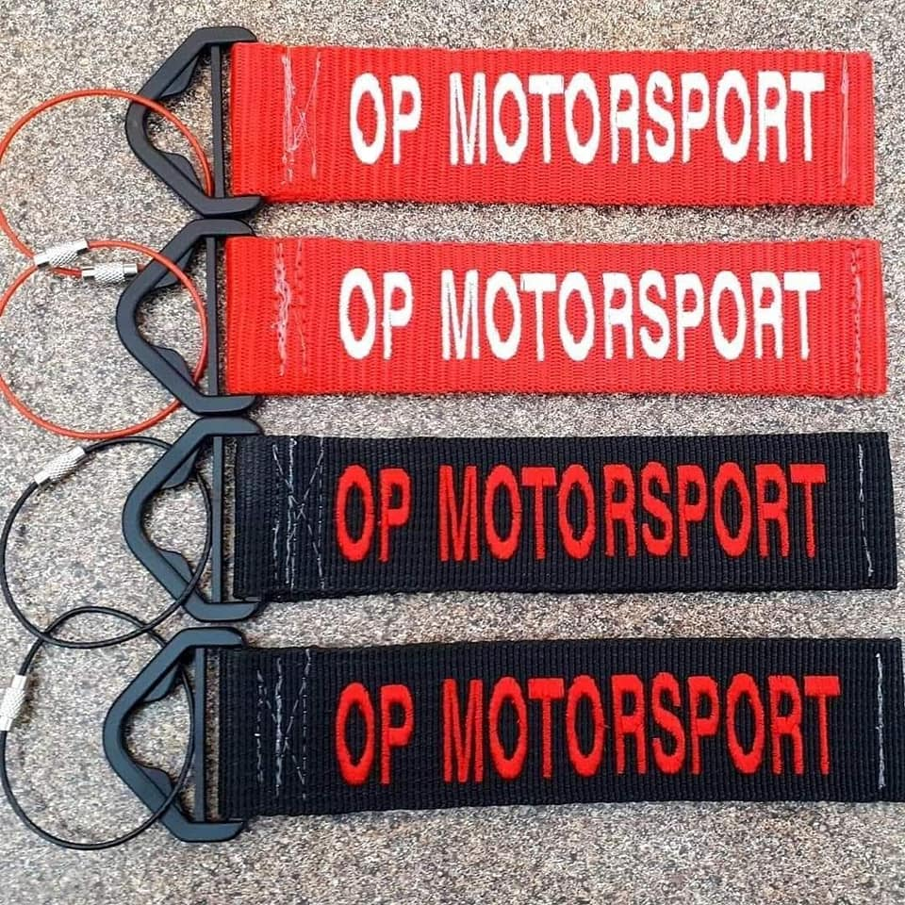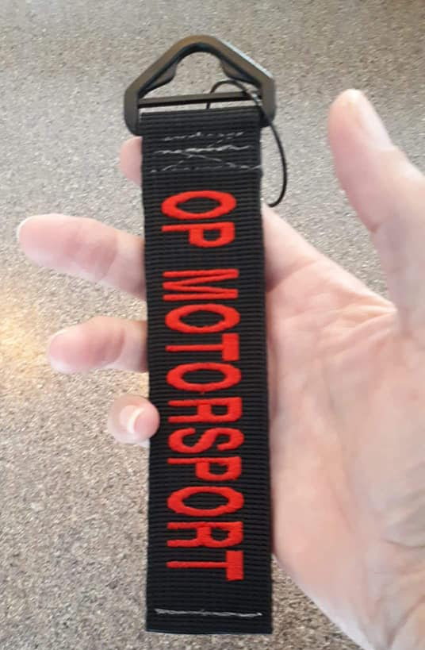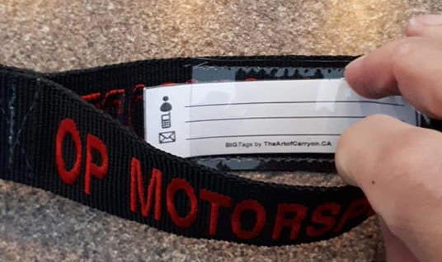

Corvettes of the D – 2014 t’s – small or medium only $10

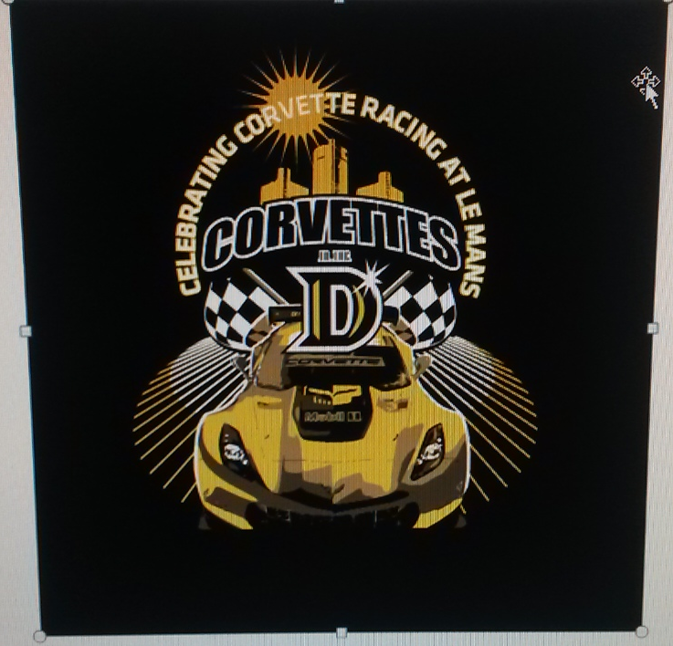

CTMP track decals – great for your race helmet or your car (white only) $7 CAD

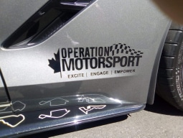

Op Motorsport Car decal (black or white) $30 CAD

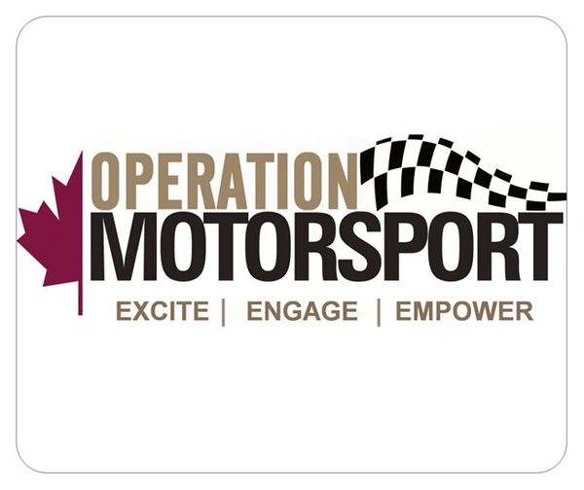
OpMo Mouse Pad …
6" x 8" Official Logo White mouse pad
$10

If you would like more information about Operation Motorsport, please go to: operationmotorsport.org

As many of you know, we try to do as much advance registration for the Corvette Corral as possible to cut down on time and paperwork (this is separate from the track ticket sales). If you have purchased your Corvette Corral tickets and have not let us know, please drop me a quick line when you order your tickets so we can add you to the preregistered list.

We have a Facebook event page that we will regularly post updates on along with information on our silent and live auction efforts to benefit Operation Motorsport. We will also post the Corral schedule as soon as it is finalized (usually 7-10 days in advance of the event).
https://www.facebook.com/events/2249622148434098/
https://www.facebook.com/events/312413652775892/
Cheers .. Janet and Nick
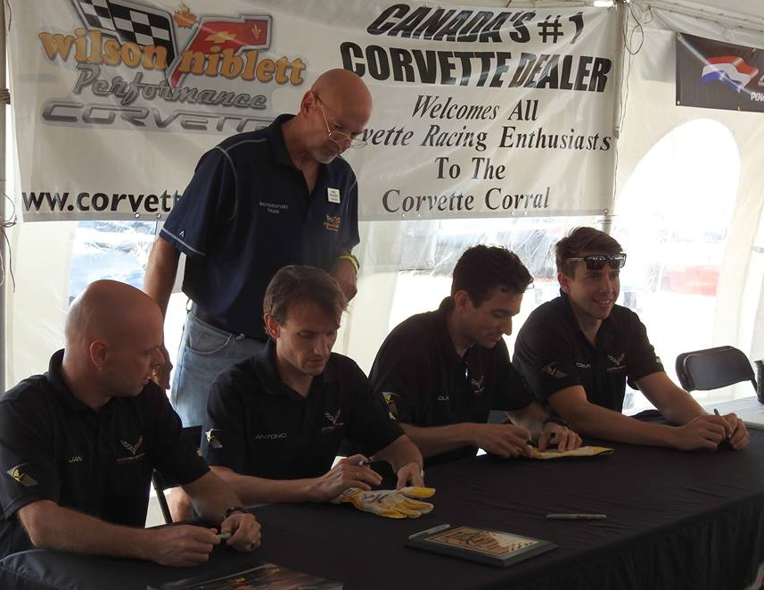
On behalf of the Wilson Niblett CTMP Corvette Corral Motorsport Team

